

**Master Thesis**

**Name, Surname: VENKATESH GOWD SOMASAMUDRAM**

**Matriculation Number: 3105094**

**Intake: WiSe-19**

**Study Program: Master of Science,**

**Focus on Big Data & Artificial Intelligence**

**Master Thesis Topic: A case study with renewable energy sector data analysis, a special focus on deep learning**

**Date, Candidate´s Signature : , Venkatesh Gowd Somasamudram**

**Date, SRH/First Supervisor´s Signature:**

**Date, External/Second/Professorial Supervisor´s Signature**

Affirmation in lieu of oath

**Somasamudram, Venkatesh Gowd**

**Matriculation Number:** 3105094

**Title of Thesis:** A case study with renewable energy sector data analysis, a special focus on deep learning

I hereby declare in lieu of an oath that I have produced the aforementioned thesis independently and without using any other than the aids listed. Any thoughts directly or indirectly taken from somebody else´s sources are made discernible as such. To date, the thesis has not been submitted to any other board of examiners in the same or a similar format and has not been published yet.

**Berlin, 24.03.2023**

**Signature**

# Abstract

Image recognition is the process of detecting the objects, features and classifying them. Image recognition works based on different algorithms like CNN (Convolutional Neural Network), Haar Cascade, MLP (Multilayer Perceptron) & Auto encoders. In this project, we are using a Deep Learning approach YOLOv5s, YOLOv7 & MobileNet SSD v2 to detect the objects. Gathering the data from one of the company’s databases, where a vast number of images of various system components are available will be used and after initial pre-processing steps the images will be classified depending on their features (size or shape), and to check whether the detected objects’ assembly meets the company standards. Later the model will be evaluated using the Recall, Precision, F1 measure and Accuracy.

ACKNOWLEDGEMENT

I would like to extend my sincere gratitude to my supervisor xxx and Technische Universität Berlin, for giving me strength, knowledge, ability, and opportunity to undertake this thesis. I extend my sincere gratitude to xxx, xxx, support, and guidance to complete this thesis satisfactorily. I am thankful to all my mentors and colleagues for their worthy guidance which has led me to complete the thesis within the timeline. I would also like to thank my parents for the constant motivation, support, appreciation, and their keen interest in my academic achievements. I also could not have undertaken this journey without my friends and well-wishers, whose assistance, motivation, and prayers have always been with me

**Table of Contents**

**Abstract 2**

**Introduction 2**

**Literature review 4**

Key concepts 4

Metrics for evaluating Object Detection Models 11

Multi Stage Detector 12

TensorFlow and YOLO 14

YOLO v5 Model 17

YOLO v7 24

MobileNet SSD v2 29

Research Gap 32

**Methodology 32**

Data Augmentation 34

List of figures

List of tables

# Introduction

Enpal has embarked on a start-up journey to make sustainable living easier and more affordable for customers in the renewable energy market by offering a new idea of Renting solar panels instead of buying them. The idea caught the attention of the German market and led to significant growth of the organisation, leading to expansion across Germany.

The customer journey begins with a sales call after registration in the portal, later many factors are considered like the credit score of the client. The journey ends with the installation switching on the Solar panels and integral components of the system. Apart from the Solar panels, Enpal offers additional devices: to store the energy using Battery, Wallbox to charge the electrical cars. Initially the company used to follow the traditional approach using Excel sheets for handling the data, now as the company is expanding, they moved to Salesforce, a customer relationship management software, a common platform for all the employees in the company.

During the installation, the company follows certain protocols starting from installation of hooks on the roofs, connecting inverter, battery, metre box and finally connecting the wall box. The installation process starts from the roof of the house. It is a proven approach to start assembly from the panels. The Panels are positioned in a way to have a maximal exposure to the sun. The craftsmen start with installing hooks and arrange horizontal rods parallel to each other with separation of 35cm**,** the arrangement of panels will depend on the size of the roof. Similar procedure is followed for fitting the Inverter, Battery, and Wallbox. The company uses internet connections such as mesh repeater, D-Link adapter or ethernet cable and in recent times 4G devices for the transmission of real-time energy production and consumption date, as well as other readings from the other components of the system.

The company follows a systematic approach for the customer journey. The customer journey ends after being tagged as ‘closed-successful’ by the Portfolio-Management department. During this stage checking the asset and monitoring if the assembling of the products meets the company standards. This stage the final control of the asset (system) is done to ensure its compliance with the company standards. For example one of the pivotal stages is the installation of the system, where the risks for the company are high. To monitor this process, an installation protocol is prepared which includes detailed documentation of key activities. An installation standard was developed by the company to check if all the quality requirements are met. A full overview image data is also incorporated into Installation protocol. The images cover the roof with under structure and hooks, panels.

The manual inspection of images consumes a lot of time. Here a deep learning approach is employed to solve the issue by training the model with necessary information to tackle time limitations and allow the Portfolio Management and other teams to meet their daily goals.

# Literature review

Following the main purpose of the master thesis, the study first of all attempts to analyse the existing body of literature related to image recognition and object detection. The primary focus was covering the entire range of research from the fundamental works that have set the foundation for main directions in these fields to the most progressive state of the art publications that try to step beyond the established boundaries. Before proceeding to the overview, it is important to outline certain key concepts that will allow us to better grasp the realms where the study steps into.

## **Key concepts**

The main entrance point of our research can be considered ***data analysis***, that practically refers to gathering, cleaning and preprocessing and analysing loads of information for the predefined or explorative purposes. Tasks of higher complexity that require application of more sophisticated logic as well as mathematical and statistical tool sets can sometimes be too heavy to handle with conventional approaches. Hereby a gradual transition was made toward full scale integration of computing tools with the human intellect. This gave rise to the concept of ***Artificial Intelligence*** (AI) [6].

The variety of topics where AI is actively utilised is great, including visual perception, speech recognition, decision-making, and natural language processing [{Updating}](https://www.zotero.org/google-docs/?qNh7vt). ***Machine learning*** (ML) is the main bearing pillar of AI. With the help of machine learning models large amounts of data can be fed and processed by the algorithms that are written either for generic purposes or have a very narrow application. Primary idea is to allow computers to go through learning cycles and optimise their behaviour with the aim to produce better results.

**Fig: The Combination of Artificial Intelligence and it subsets Machine and Deep Learning[6]**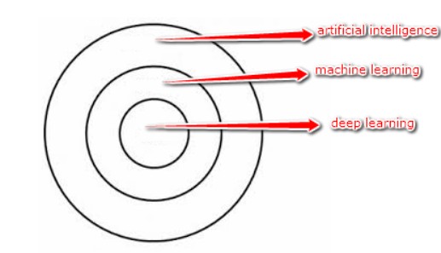

***Supervised Learning***

In supervised learning (SL), the output comes based on the labelled input data which is called trained data. Firstly, train data with labels based on certain parameters. By reference if the labelled data, Supervised learning algorithms predicts and gives the output. It is called supervised learning as it learns and predicts output in the supervision of labelled data.

In the real-world, SL is used for Image classification, Spam filtering, Fraud detection, Risk Assessment. By taking an example of Vehicles dataset to show how SL works. The dataset consists of Cars, MotorBike. Secondly, training the model for each class of vehicle.

1. If the Vehicle has four wheels, the model predicts as Car.
2. If the Vehicle has two wheels, the model predicts it as a Bike.

Based on the features for instance wheels, the output will be predicted by the model on the given input image. The Models that use SL are Linear and Logistic Regression, SVM (Support Vector Machines), Naive Bayes, Neural Networks, and Decision tree.

***Unsupervised Learning***

Unsupervised Learning (UL) doesn’t rely on labels for training, the model learns from the hidden patterns and insights. The goal is to find the underlying structure of the dataset and group them according to similarities. Initially, the UL learns the dataset by dividing them into clusters based on similarities like length, width etc on its own. Finally, it predicts the output according to the clusters it generated based on observation.

In the real world, UL is used for Data exploration, Semantic clustering, Target Marketing Analysis. For instance, consider the data set containing trucks and buses, by examining the parts of vehicles such as length of truck & bus and type of wheels, front and rear covers, roof hoods etc. In the end the model will predict according to the common features. K means clustering, K nearest neighbour, Neural Networks and Apriori algorithm are few models that use UL.

***Deep Learning (DL)***

Deep Learning is another part of AI and subset of ML, DL is inspired by the information flowing through the neurons in the human brain and mocks the same. When we acquire new data, the brain compares it to a known object before making sense of it, which is the same notion used by deep learning algorithms. In order to train ML features are required to insert manually, whereas DL will identify the features and trains on it. DL needs a large amount of data to make decisions [6].

***CNN mode***

CNN (Convolutional NeuralNetwork) came into existence in 1998, author Fukushima presented in his paper [33]. CNN is simulated of neurons which stack up and form a layer, each neuron has weights and biases .CNN can be implemented in various fields such as Image classificaiton, sentence classification, Object detection, object segmentation, recognition of text and face recognition [32]. There are few major models using CNN as architecture which are available as follows: LeNet, VGGNet, ZFNet, ResNet, AlexNet, SENet, Inception model, Xception model, MobileNet V1/V2. etc.In order to get the better accuracy and performance of the model, one should need a high level GPU and large amount of data.

CNN architecture followed by different models for the purpose of image processing and computer vision, in general object detection. It falls under the umbrella of Machine Learning. There are different types of models available which are using the CNN architecture depending on the requirement we choose. The models are trained on ImageNet dataset, so the model can be used for classification. But when it comes to drawing a bounding box and labelling the object there are few approaches possible. There are two different stages of object detection i.e., multi-stage (two stage) detectors and single stage detectors.

Multistage detectors or two-stage detectors recognize the object based on region of interest or bounding boxes. This can be achieved by classifying images as well as localization (which points exactly at the coordinates of the object) due to its high consumption of time and computation. I have chose SSD (single shot detectors) in this master thesis, before proceeding to the approach of object detection, multistage detectors and single stage detectors of different types are discussed, all the object detecting models uses mAP (mean Average Precision), Recall, Precision and F1-score as common metrics for object detection to check the performance of the model. Below is the architecture of VGG-16.

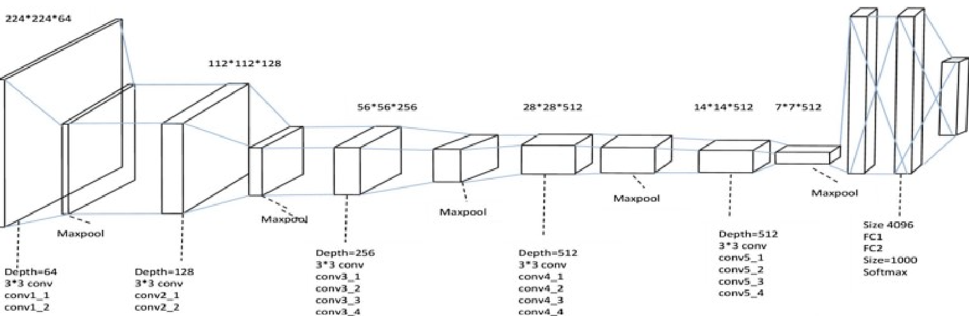

**Fig : Architecture of VGG-16 based on CNN [32]**

***Transfer Learning***

Conventional machine learning approaches use the presumption of training and testing data coming from the same field, in such a way the format of these features are the same. But when it comes to the real world scenarios the computation of big data is highly expensive and time consuming. So there is a need to create models that are trained and the data for this model needs to be fetched from various domains (Karl Weiss et al. [50]). This process is known as Transfer Learning (TL).

There are few models available that use TL such as VGG16, RESNET, ALEXNET. These models have inbuilt trained weights. These trained weights are that can be used for other models. TL is born to save computation, time and processor. All you need to do is to train the model’s final dense layer with the user's input features.

***Image classification***

Image classification is a technique of identifying an image by reading the image in the form of pixels of matrix, the input image is converted to an array and gives a probability of how likely the output belongs to a specific class.

Again the classification has two different types of images 2D image which is Black and white and another 3D image which is the combination of RGB (Red, Green and Blue) all the image in the real world will be based on this three different channels, the vector converted image values values from 0 to 255 where 0 is black and 255 is white and same applies for 2D (adding 2 times of input image pixels) & 3D RGB (adding 3 times of input image pixels) [1].

***Object detection***

While classifying an image, we incur with multiple objects in a single image classification will help in giving the probability for all the classes in the image but it will not show where the class is exactly located. Here comes the Object detection, from the author Vincent with three different types Localise, Classify and Non max suppression.

Before describing the above three there is a concept of Anchor boxes [2] which is basically for every object in an image there will be thousands of predictions covered by anchors, which will be compressed in a way that max overlapped anchor of the object will be compared with all other non overlapped anchors which is termed as IOU (Intersection Over Union). By telling the anchors boxes or IOU that covers over more than 50% percent of the object will be considered as an object (The highest percentage of the anchor box will be considered as object) .

* Object Localization: Mark the ROI (region of interest) using Annotations (creating labels for selected region that generates coordinates (x,y,Height,Width,Class)) there are tools to markup the ROI for example: LabelImg
* Object Classification: Extracting the features of the bounding boxes and using the regressor to check how much the anchors vary from the actual reality of the object or ground truth.
* Non Max suppression: It is responsible to maintain only one anchor box by eliminating all other non overlapping anchor boxes.

***TensorFlow***

TensorFlow is a framework created by the Google brain team for Machine Learning computation, as it provides GPU, TPU to implement on the Cloud. Tensorflow or TF uses a concept called Neural networks when an input (speech, text, image or video) is passed through the layers of neurons and trains the model until it is able to detect the output that is desired by the user. Machine Learning (ML) lacks fine tuning and retraining the network for the performance improvement that’s where TF comes to the existence, TF contains a vast number of builtin libraries that can be used for training, testing and evaluating the Model. TF is designed based on the human brain.

***Keras***

Keras is a Deep learning API which is part of TF. It is used for faster computation and reduces manual effort of coding, it contains neural network properties such as sequential and functional api’s [3].

* Sequential API: Complete neural network models are built using Keras.Sequential, each layer by layer is stacked up with neurons each neuron accepts one input tensor.
* Functional API: It is an alternative approach for Sequential which is more complex used mainly for residual neural networks (ResNet) , it can go back to the previous layer and make it as input for the current layer.

***Tensor Board***

Tensor board is a visualisation board used to monitor the progress of the model during training and take necessary steps to prevent Underfitting and Overfitting of the model (David C. Vogelsang et al [53]). Bias[1] and Variance[2]. Underfitting and overfitting are two common challenges in machine learning.Underfitting occurs when a model is too simple to capture the underlying patterns in the data, which results in suboptimal performance on both the training and validation datasets. On the other hand, overfitting occurs when a model is too complex and not only captures the underlying patterns but also the noise in the training data, leading to high performance on the training dataset but poor generalisation on new data.

***Darknet Framework***

It is a framework used for object detection with fast and accurate results. It is written in C. Advanced implementation of deep neural networks can be done using darknet. These implementations include YOLO, RNNs, ImageNet Classifications. The biggest advantage with this network is that training and validation are easier whereas other frameworks are sometimes heavily optimised for training and validation across other data sets, then it becomes a difficult product. Darknet can be installed easily with two optional dependencies openCV when we need support of multiple image types or CUDA if we need GPU computation and neither is mandatory. Darknet can handle Recurrent Neural Networks(RNN) which are used to represent data that keeps changing over time. Darknet displays information by loading the config file and weights then it classifies the image and prints the top 10 classes for images [7].

***Pytorch Framework***

It is a framework used for building deep learning models like image recognition and language processing. It is written in python. It supports well for GPUs and its use of reverse-mode auto-differentiation. PyTorch combines flexible GPU accelerated backend libraries like torch with a python frontend that focuses on prototyping, readable code and supports a possible variety of deep learning models.

PyTorch uses the programming approach but still outputs a graph. It is easy for the python developers to learn as it uses python libraries for integration. It also supports cloud platforms. There is a repository called PyTorch Hub which contains pre-trained models that can be used just with a single line of code in some cases.

PyTorch adopted a chainer innovation called reverse-mode automatic differentiation. It is like a tape recorder that records completed operations and then replays backward to compute changes which makes it easy for debugging and adds adaptability for networks. It also supports enabling network changes over time. PyTorch has two core components:

* 1. Tensors : Tensors are data types which act similar to multidimensional arrays in python. These are used to store inputs, outputs and model parameters.
* 2. Graphs : Graphs are data structures consisting of connected nodes and edges. PyTorch keeps a record of tensors and executed operations in a Directed Acyclic Graph(DAG) consisting of objects [7].

## **Metrics for evaluating Object Detection Models**

***Mean Average Precision or mAP***

The Mean Average Precision or mAP is a metric is used to measure the accuracy of object detection. In general bounding box used for predicting objects inside image and box includes height, width and (x, y) parameters (see Eq. 1).

$BoundingBox = \left[B_{x}, B_{y}{, B}_{h}{, B}_{w}\right]$***Eq. 1***

An object can be surrounded by multiple boxes and in order to predict the most accurate box Intersection over Union (IoU) is used. IoU compares the boxes with the ground truth box and eliminates all the boxes with low scored.

IoU = Area of Overlap / Area of Union ***Eq. 2***

***Precision, Recall and F1 Score***

The metric is used to find all the correctly predicted , Precision is calculated as the number of positives by the sum of true and false positives.

Precision(P) = TP/(TP+FP) ***Eq.3***

The metric is used to find only the correctly predicted per class, Recall is calculated as number of true positives by sum of true positives and false negatives.

Recall(R) = TP/(TP+FN) ***Eq.4***

It is the mean of an individual's performance based on precision and recall.

F1 = 2*(P*R)/(P+R) ***Eq.5***

## **Multi Stage Detector**

***Regions with Convolutional Neural Network (RCNN)***

It uses a selective search approach which uses segmentation of image into various blobs by telling what can be an object by calculating the similarities between the nearby regions until it covers the whole region. It has a default method of using 2000 areas that needs to be checked inside an image. After all the regions are covered, features will be extracted and passed to the classification where RCNN used the SVM (Support Vector Machines) and Bounding box regression for classification and localization. Here are some general specifications of the model:

* Using Selective search itself computationally takes a huge amount of time.
* Training the SVM and CNN is another tough procedure.
* It takes 47 seconds for classifying one image

***Fast RCNN***

It is more than slightly different from RCNN. At first the CNN which is the first layer used for the feature extraction, is applied, then the region of interest (second layer) 2000 areas is applied at a single time, this improves the model to perform faster. It uses Softmax[3] as an activation function and the bounding box regressor for the classification which is integrated along with the model. Here are some general specifications of the model:

* Computes 9 times faster than the RCNN
* It takes 0.32 seconds for classifying one image
* Drawback of applying CNN for 2000 areas makes it more complex (takes a long time to get trained).

***Faster RCNN***

It is faster than the fast RCNN, the only difference it makes is RPN (Region Proposal Network). It means the first step would be to have only one CNN layer applied on the image to get the bounding boxes and to extract their features for the classification. Later the classification utilises a bounding box regressor, increasing ROIs (Region of Interest). Here are some general specifications of the model:

* After creating bounding boxes, this model offsets the anchor boxes, having default size and shape. It increases the performance of the model as it only considers the desired bounding boxes.
* It takes 0.10 seconds to classify an image.

***Single Shot Multibox Detector***

The single shot detector is built on pre-defined weights to extract the features with architectures like VGG16, ResNet, Alexnet etc. the SSD (Single Shot Detector) will add other convolution layers and takes out some feature maps from the CNN architecture and extra layers added on it.

It creates grid maps by extracting feature maps from the outputs of different CNN layers, the grid map having different size and shape. In order to choose the best fit of the bounding box Non max suppression is used.

In the entire CNN architecture journey it uses total count of 8732 (it is the multiplication of pixels of each convolutions * 4 bounding boxes per convolution) as bounding boxes or the number can be called as total predictions for 1 image. It can be faster than the Faster RCNN as it achieves mAP of 74% with 59 FPS

## **TensorFlow and YOLO**

According to the paper YOLOv3: An Incremental Improvement by [(Redmon & Farhadi, 2018)](https://www.zotero.org/google-docs/?pMvzAh), TensorFlow is one of the frameworks that can be used to implement the YOLO algorithm. The authors mention that they provide "official implementations in C, Darknet, and TensorFlow".

In other words, TensorFlow can be used as one of the implementation options for YOLO. This means that YOLO can be built and trained using TensorFlow's APIs and tools, and also benefit from TensorFlow's additional features like model evaluation and deployment.

***YOLO v1 (You Only Look Once)***

YOLO is similar to the SSD as the only difference is the use of only 98 predictions during the convolution. As a result, this approach has a decreased rate of prediction with mAP 63.4 and FPS 45, speed is more compared to previous version. This is the first version of YOLO and it was released prior to SSD. This Version is not as good as SSD for localization and it has problems with size of the objects in the training dataset. Though there are many versions we need to look into for the comparison, which will be discussed below.

The first version of YOLO is v1, it uses RPN (regional proposal network) as an algorithm along with SSD. The RPN is trained on the Imagenet, COCO and VOC datasets, which helps the RPN algorithm be able to classify the regional proposals. YOLOv1 has significantly better performance in small scaled objects, aerial images.

The YOLOs using v1 they are, A New Method of Image Detection for Small Datasets under the Framework of YOLO Network [(G. Li et al., 2018)](https://www.zotero.org/google-docs/?UC4Vnm) , A Vehicle Detection Method for Aerial Image Based on YOLO [(Lu et al., 2018)](https://www.zotero.org/google-docs/?yE68hj), Object Detection Based on YOLO Network [(C. Liu et al., 2018)](https://www.zotero.org/google-docs/?ykTlnt) In the research conducted by [(C. Liu et al., 2018)](https://www.zotero.org/google-docs/?GDrwkC) [36] it is stated that training the model by providing additional data that includes degraded images such as jitter, noise and blurred will help the model to learn more and achieve better results.

***YOLO v2***

In the v2 version new approaches have been added such as anchor boxes instead of bounding boxes and batch normalisation for improving the process of learning and decreasing the epochs.

The classifier resolution to 448 x 448 which made the classifier achieve the mAP of 76.8 and FPS of 67, whereas the first version is 224 x 224 which makes one of the reasons for the low performance in prediction.

Here the anchor boxes play a very important role. I When identifying objects one should be aware of tuning the anchor boxes in order to check if the coordinate point does lie exactly between the centre of the anchor box. Determining which object's bounding box has the biggest overlap compared to non-overlap for each anchor box is called Intersection Over Union or IOU. The model uses Darknet-19 as the model architecture instead of VGG, which was supported by the batch normalisation.

The second version of YOLO is YOLOv2(v2),this version showed better results by improving rate of recall, detecting location of the object and maintaining accuracy. Here are few citations which are used for the purpose of object detection, A Real-Time Chinese Traffic Sign Detection Algorithm Based on Modified YOLOv2 [(J. Zhang et al., 2017)](https://www.zotero.org/google-docs/?cJ6MFK) [37], Automatic thyroid nodule recognition and diagnosis in ultrasound imaging with the YOLOv2 neural network [(L. Wang et al., 2019)](https://www.zotero.org/google-docs/?PkmCdB) [38] , An Improved YOLOv2 for Vehicle Detection [(Sang et al., 2018)](https://www.zotero.org/google-docs/?IvITM0) [39] , and Fighting against COVID-19: A novel deep learning model based on YOLO-v2 with ResNet-50 for medical face mask detection [(Loey et al., 2021)](https://www.zotero.org/google-docs/?iyRrKQ) [40]. In the research conducted, normalisation of the model from [(Sang et al., 2018)](https://www.zotero.org/google-docs/?5REWaL) [39] helps the model to learn from the object at different scales by improving the calculation of loss on bounding boxes length & breadth, it can be used as reference for future implementations.

***YOLO v3***

Unlike the YOLO version 2 this version has few changes that enhanced its performance compared to the previous version. One change is the use of Sigmoid[4] activation function rather than Softmax. Also it uses the architecture of Darknet-53 which is further deeper, which has 53 layers of convolution. The reason for these changes is that there might be different instances that can arise when identifying the object. For example, if a model identifies an object to be an apple and fruit, which one should be chosen? This architecture uses a threshold of 0.5 (50 percent of prediction as starting point) and uses loss function that passes to bounding box, objectness, and prediction of class in order to get classified. Otherwise , it uses a conventional bounding box. Unlike the YOLO v2, it has the anchor boxes by having the biggest overlap box to pick the class of the object.

Note: The above values used for the metrics are based on the pretrained COCO dataset.

YOLO Version 3 with different pixel size provides valuable information like increase in the pixels results in increase in metrics accuracy for prediction. It achieved mAP 51.5 for the pixels of 320 X 320 with the computation time of 22ms, for 416 X 416 it took 29ms with mAP 55.3 which is longer compared to the first pixels approach, by adding more, 608 * 608 pixels took the time of 52ms with a mAP of 57.9.

If we take the Faster RCNN, it will take 172 ms for 608 x 608 pixels with a mAP of 59.1 and the version of YOLO v2 for 608 x 608 pixels gives a mAP of 48 with a time of 40ms.

YOLOv3 (v3) is popular for its speed and accuracy compared to v1 and v2; the citations made by scholars have produced promising results. Here are a few citations of (v3) that can be used as reference for deploying v3 in real time. Real-Time Hand Gesture Recognition Based on Deep Learning YOLOv3 Model [(Mujahid et al., 2021)](https://www.zotero.org/google-docs/?JVm59b) [44], Optimized YOLOv3 Algorithm and Its Application in Traffic Flow Detections [(Huang et al., 2020)](https://www.zotero.org/google-docs/?lEgwrS) [43], Car Detection using Unmanned Aerial Vehicles: Comparison between Faster R-CNN and YOLOv3 [(Benjdira et al., 2019)](https://www.zotero.org/google-docs/?bUySmR) [42] and Apple detection during different growth stages in orchards using the improved YOLO-V3 model [(Tian et al., 2019)](https://www.zotero.org/google-docs/?PhtH1g) [41]. In the research conducted by[(Mujahid et al., 2021)](https://www.zotero.org/google-docs/?nTYHGf) & [(Huang et al., 2020)](https://www.zotero.org/google-docs/?Bv1Dez) [43] it stated v3 performs better over F-RCNN in terms of performance and speed. All citations provided above use Darknet-53 as a convolution layer for better feature extraction and reusability of the features.

***YOLO v4***

This version of YOLO predicts 10% better than version 3 and inference time is 12%. V4 uses two different techniques such as Bag of Freebies[5] and Bag of Specials[6] [(He et al., 2018)](https://www.zotero.org/google-docs/?Bidv3m), where freebies are used for improvising the accuracy without increasing time of inference by increasing training cost. Meanwhile, specials are used in order to improve the accuracy. It slightly increases the inference time for the purpose of detecting the object.

YOLOv4 (v4) is based on YOLOv, v4 uses Cross Stage Partial connection (CSP) is a network of darknet, which acts as backbone architecture, [(Deng et al., 2020)](https://www.zotero.org/google-docs/?3BkdKc) [45] CSP improves the network speed, performance, enhancing features and reusing features by optimising the network size. FPN (Feature pyramid network) is replaced by PANet(Path Aggregation network) for boosting the flow of information. In comparison with previous versions v4 increased by 10% and 20% . These are a few citations using v4 for the purpose of object detection. A Detection algorithm of cherry fruit [(Gai et al., 2021)](https://www.zotero.org/google-docs/?pmndWl) [46], A real-time detection approach for bridge cracks based on YOLOv4-FPM [(Yu et al., 2021)](https://www.zotero.org/google-docs/?0NfH3o) [47], Deep convolutional neural network for enhancing traffic sign recognition developed on Yolo V4 [(Dewi et al., 2022)](https://www.zotero.org/google-docs/?GlDfEY) [48] and Real-time detection of uneaten feed pellets in underwater images for aquaculture using an improved YOLO-V4 network [(Hu et al., 2021)](https://www.zotero.org/google-docs/?73MDOY) [49]). By including additional modules such as CSP connection, weighted residual connection, adversarial training, Mosaic augmentation [(Deng et al., 2020)](https://www.zotero.org/google-docs/?Xh2f09) [45] etc. The performance of the model is improved in terms of speed and accuracy in comparison to previous versions.

## **YOLO v5 Model**

This version of YOLO is meant for its speed and accuracy.The reason for using v5 is that it is lightweight (up to 27 mb) and is built on Pytorch framework which is easy to install and use. Whereas previous versions used C and weighs up to 244 mb. The model has very promising architecture. Instead of Darknet it uses Pytorch by CSPDarknet53 as the architecture.

In general multistage detectors the process is as follows. First stage CNN is responsible for feature extraction and neck is responsible for the feature aggregation and dense prediction For localization, classification and detection,second stage RPN (region proposed network) or sparse detection is used as end predictor. These two stages are combined together into a SSD YOLO v5.

***Reason for choosing the Yolo v5***

YOLOv5 is a widely used object detection model that has gained a reputation for its speed, accuracy, and ease of use. Various studies have compared its performance to other state-of-the-art models and found that YOLOv5 achieves superior accuracy and faster inference times. For instance, a study by Alphons Gwatimba and Jong-Hwan Kim (2021) showed that YOLOv5 outperformed other models such as EfficientDet and RetinaNet in terms of accuracy and inference time. Another study by Lingxiao Yang et al. (2021) compared YOLOv5 to other models, including YOLOv4, EfficientDet, and Faster R-CNN, and found that YOLOv5 achieved higher accuracy and faster inference times. Moreover, YOLOv5 has been reported to be effective in challenging environments, such as low-light and occluded conditions. Its streamlined architecture and easy-to-use API make it accessible to researchers and practitioners of different expertise levels. In summary, these studies demonstrate that YOLOv5 is a highly effective object detection model that outperforms other state-of-the-art models in terms of speed, accuracy, and ease of use, making it a popular choice for various applications in the field of computer vision.

***YOLOv5: Literature Review***

Here are citations of YOLOv5 for the purpose of real time applications. YOLO-FIRI: Improved YOLOv5 for Infrared Image Object Detection [(S. Li et al., 2021)](https://www.zotero.org/google-docs/?doCYiX) , YOLO-Z: Improving small object detection in YOLOv5 for autonomous vehicles (Benjumea et al.), Object Detection and Classification Based on YOLO-V5 with Improved Maritime Dataset (Kim et al.), Evolution of YOLO-V5 Algorithm for Object Detection: Automated Detection of Library Books and Performace validation of Dataset (Karthi et al), Object Detection Method for Grasping Robot Based on Improved YOLOv5 (Song et al.).

Based on interest, only few have been chosen for the purpose of this research. Improved YOLOv5: Efficient Object Detection Using Drone Images under Various Conditions [(Jung & Choi, 2022)](https://www.zotero.org/google-docs/?vSVWls)), Accurate and automated detection of surface knots on sawn timbers using YOLO-V5 model [(Fang et al., 2021)](https://www.zotero.org/google-docs/?iMOb5H), A Real-Time Detection Algorithm for Kiwifruit Defects Based on YOLOv5 [(Yao et al., 2021)](https://www.zotero.org/google-docs/?cafDCk), A novel detection method for hot spots of photovoltaic (PV) panels using improved anchors and prediction heads of YOLOv5 network [(Sun et al., 2022)](https://www.zotero.org/google-docs/?OYWv1z), [TPH-YOLOv5: Improved YOLOv5 Based on Transformer Prediction Head for Object Detection on Drone-captured Scenarios](https://ieeexplore.ieee.org/document/9607487/) [(Zhu et al., 2021)](https://www.zotero.org/google-docs/?zTg5mX), Apple stem/calyx real-time recognition using YOLO-v5 algorithm for fruit automatic loading system [(Z. Wang et al., 2022)](https://www.zotero.org/google-docs/?GHsvhj), Short Communication: Detecting Heavy Goods Vehicles in Rest Areas in Winter Conditions Using YOLOv5 [(Kasper-Eulaers et al., 2021)](https://www.zotero.org/google-docs/?MOHrOM), and Solar Cell Surface Defect Detection Based on Improved YOLOv5 [(M. Zhang & Yin, 2022)](https://www.zotero.org/google-docs/?4PL25X).

| **Fig: The architecture flow of YOLOv5 network (Renjie Xu et al.[54])** |
| --- |

According to the paper "YOLOv5: A Universal Object Detector” by Glenn Jocher et al., the YOLOv5 architecture employs a CSPDarknet53 backbone for extracting features from the input image. This backbone consists of a cross-stage partial network that enhances feature representation while minimising computational complexity. Following feature extraction, YOLOv5 applies a neck module that uses a combination of Path Aggregation Network (PAN) and Spatial Pyramid Pooling (SPP) to generate multiscale feature maps. These feature maps are then passed through a sequence of convolutional layers, including upsampling layers, which improve their resolution. Finally, the feature maps are utilised for object detection by predicting the bounding boxes and class probabilities of objects present in the input image.

1. Yiming Fang et al. in his research stated that when using the YOLOv5 (v5) shows outstanding results compared to YOLOv3 (v3) and Faster R-CNN, the reason behind choosing v5 is because of its training speed and size of the weight file. The training time for Faster R-CNN is 11.25hours which is nearly 155 times compared to v5 and weight file size of 110.718 megabytes and RCNN is trained on RESNET50 architecture over 1000 epochs with a batch size[7] of 4, Similar training epochs and batch size applied for v3, where the training time is 8.515h and the weight file is 244.8 megabytes i.e., is 6 times larger than v5. When it comes to the dataset of v5, the author split the data in a way, out of 374 images 305 used for training, 36 for validation and 33 for testing. The results are, for precision, the training and testing are 99.7% and 91.7%, and for the validation 94.7%. Recall of the training and testing data set is 100% and 91.7%, and for the validation it is 97.3%. The Author says that during validation the model is able to detect 36 knots in total of 37, provided there were two outliers. Model performance on the testing dataset was maintained i.e.33 in total of 36 knots was predicted. To make the comparison of accuracy among all the models, the author uses two different datasets, both of the datasets belong to detection of Knots on a wood. Finally, the author concludes from his proposal, when using 80% of training data he observed the detection accuracy is higher, when compared with the dataset that used 70% for training [(Fang et al., 2021)](https://www.zotero.org/google-docs/?BIYIez) [9] .

2. For the purpose of improving detection of objects, author [(Kim et al., 2022)](https://www.zotero.org/google-docs/?0ob4RJ) gives example by comparing YOLO v5 with and without augmenting and annotating, he uses Singapore Marine Dataset (SMD) which is video annotated data, containing irregularities in annotations that makes it less robust in performance and classifying objects. Additional images, which are very less numbered in their own class, were provided by data augmenting in order for the model to well understand, differentiate and reduce the imbalance problem of classes. In order to improve the model the author uses augmentation for data disparity, and corrects the annotations and named it as SMD-plus and trains the model, the augmented v5 SMD plus increased its performance and object detection as compared to the same version with SMD [10]. Author concludes the model as a benchmark for the future, it will be used as a monitoring tool in real time scenarios on sea environments.

3. For the purpose of Real time detection on defect of kiwi fruit author [(Yao et al., 2021)](https://www.zotero.org/google-docs/?9Wc0u4) proposed in his paper using YOLOv5 (v5), the existing models are not meeting the requirements of the author especially when in comes to the small object detections and speed, so author stackup small targeted layer for v5 to detect small defected objects, adds another Squeeze and Excitation or SELayer [(Cheng et al., 2018)](https://www.zotero.org/google-docs/?lu1PZr) [11] in order to increase the model's capability of identifying features. When it comes to improve the factors of geometric author refers to the citation of Zhaohui Zheng et al. about enhancing geometric focused on object detection [(Zheng et al., 2022)](https://www.zotero.org/google-docs/?vtfg8O) [29] when utilising the Non max suppression together with bounding box regression for the purpose of picking up the bounding box which is more closer to the ground truth, the CIOU loss function is implemented, this results in significant increases in average accuracy of precision and recall without sacrificing model's performance. Also, Cosine annealing algorithm is applied to boost the model’s learning rate, the annealing technique is different from conventional approach as the count of epoch is increased, the learning rate of the model is decreased, so during the epoch with the best learning step will be saved, and during the next iteration the model starts to run from the saved step and starts to increase in learning. Author named the model as YOLOv5-ours by utilising all the techniques mentioned above, the upgraded network YOLOv5-ours outperforms the original YOLOv5 in terms of performance in real time detection, and mAP of increased 9% more and able to make the prediction of image in 0.1s.

4. Correct identification and recognition of hot zones on photo - voltaic (PV) panels will direct to service & maintenance, make appropriate choices, improve Photovoltaic systems power production, and ensure power station safety & stability. Author Tianyi Sun et al. in their publication proposes that by upgrading anchors and fine tuning the network of YOLOv5 will generate appropriate predictions, for this purpose K means clustering technique is used for the purpose of clustering length and width ratio and the anchor boxes with less values are included in the model so that smaller number targets can be detected, aside from that, a prediction layer or head is included for the new smaller anchors for improving the precision. Finally, the model is compared with other single stage detectors which the current model produced mAP 87.8%, rate of the recall is 89% and F1 measure is 88.9%, author tells the precision of the current version if better than any other models like YOLOv3, YOLOv4 and Faster R-CNN. The FPS(Frames per second) of the model is 98.6 which can be successfully implemented in the real time tracking of hot spots [(Sun et al., 2022)](https://www.zotero.org/google-docs/?jWJ9Vy) [19].

5. Yolov5 can be implemented on drone capturing images, there are two reason to utilise this model, in the research conducted by author [(Zhu et al., 2021)](https://www.zotero.org/google-docs/?68U8mv) [20], one reason is the network to be optimised, as the drone capturing images scales at different heights and another fast moving drone takes blurred images that contains objects grouped together which in return makes object distinction difficult. For the purpose of detecting different scaled objects author adds one more prediction head for the existing model, to tackle the situation of blurred images, prediction heads (increase the prediction rate at different aspect ratios) will be replaced with Transformer Prediction Heads and convolutional block attention model (CBAM) for the purpose of identifying highlighting spots. Furthermore, the author uses the conventional methods such as augmenting techniques, testing at multi scales, integration of multiple models and additional classifiers. The dataset used for the model is VisDrone2021. Finally the results proved that model have excellent output of detecting the objects captured by drones. Compared with the original model YOLOv5, TPH YOLO v5 is 7 times higher in its performance and accuracy. To compare the mAP, the author uses the DET dataset where the TPH model achieved 39.18% whereas the other model named SOTA achieved 1.81%.

6. Yolov5 for correcting the position of Fruit during the post harvesting, as it takes so much of human intervention to do manual check of filling up the stock and parcelling. In the research conducted by the author [(Z. Wang et al., 2022)](https://www.zotero.org/google-docs/?jJx3zg) proposes that the internal quality detection of the fruit is impacted by the position of the fruit, in order to overcome the situation of manual quality inspection, real time detection bench marked YOLOv5 is utilised, at the beginning parameters are initialised and transfer learning weights are utilised, and with different aspect ratios the input data will be trained in order to get the well performed layer in the model, finally for the purpose of optimising the network pruning[8] methods like layer & channel, DHS (Detection head searching) were used. By optimising the model’s complexity, the weights reduced nearly 70% , while mAP reduced to 1.57% and F1- measure to 2.57%, therefore the model produced mAP of 88% nad F1 measure of 85% and overall accuracy of 93.8%which is a good sign compared to any other models in single shot detectors where as less in terms of multistage detector Faster RCNN [21].

7. YOLOv5 for the purpose of detecting the heavy loaded trucks during cold climatic conditions, in order to inform the administration of goods companies about the free space that can be allocated to a truck. The research conducted by the author [(Kasper-Eulaers et al., 2021)](https://www.zotero.org/google-docs/?9AFvqb) trains the model with two different approaches to confirm the most promising approach. The first approach is to train the model with trucks front facing angle and another is back side facing. Author used augmentation techniques for accurate results, pre-trained weights through transfer learning and thermal capabled camera image for training the model. To conclude, thermal network imaging holds promise for vehicle detection when winter weather creates difficult images with a lot of interference and certain cuts of image will be disclosed, as thermal image has more prediction score of bounding boxes compared to the rear end [22].

8. YOLOv5 for the purpose of detecting defects on Photovoltaic panels, from the research conducted the author [(M. Zhang & Yin, 2022)](https://www.zotero.org/google-docs/?mGD0dh) [24] uses an improvised version of the model by placing additional features such as ECA (efficient attention channel) which boosts the performance by extracting features from convolution and preserving features and reducing the dimensionality by using right cross channel method [(Q. Wang et al., 2019)](https://www.zotero.org/google-docs/?16eYs1) [23], a CSP(concentrated Solar Power) convolution is integrated to module for robust learning, and prediction layer or head to increase the prediction rate at different aspect ratios. Furthermore, in order to reduce the dimensionality and increase the performance, Mosaic along with the MixUp date enhancing, clustering of anchor boxes K-means++ and calculating the loss CIOU(complete intersection over union) are included. Finally the author presents an improvised model with a mAP of 89.64%. Whereas the original version showed mAP 81.79%. The tests are concluded based on the Solar cell EL dataset. In the end the project can be implemented in real time .

## **YOLO v7**

In order to increase the accuracy and performance of YOLOv5, the research topic focus on using YOLOv7 (v7) has been introduced by adding many layers like BConv, E-ELAN and MPConvin the Backbone instead of CSP for the purpose of the feature extraction and improvement of the performance. There were numerous topics that contains citations about v7 as proof of concept, few of them include, The Semantic Segmentation of Standing Tree Images Based on the Yolo V7 Deep Learning Algorithm [(Cao et al., 2023)](https://www.zotero.org/google-docs/?9IzS1v)**,** YOLO V7 and Computer Vision-Based Mask-Wearing Warning System for Congested Public Areas [(Eği̇, 2023)](https://www.zotero.org/google-docs/?QFL3RR), Pothole Detection using CNN and YOLOv7 Algorithm [(Reddy & V, 2022)](https://www.zotero.org/google-docs/?N78ewV), Using YOLO V7 development of Complete VIDS solution based on latest requirements to provide highway traffic and incident real time info to the ATMS control room using Artificial intelligence [(Patkar et al., 2022)](https://www.zotero.org/google-docs/?gZWIVw), Enhanced safety implementation in 5S + 1 via object detection algorithms [(Shahin et al., 2023)](https://www.zotero.org/google-docs/?j9WKhs), for the purpose of this research following citations have been used for the reference, Detection of Camellia oleifera Fruit in Complex Scenes by Using YOLOv7 and Data Augmentation [(Wu et al., 2022)](https://www.zotero.org/google-docs/?oIGEuM), YOLOv7-sea: Object Detection of Maritime UAV Images based on Improved YOLOv7 [(Zhao et al., 2023)](https://www.zotero.org/google-docs/?C9Zr9K), IDOD-YOLOV7: Image-Dehazing YOLOV7 for Object Detection in Low-Light Foggy Traffic Environments [(Qiu et al., 2023)](https://www.zotero.org/google-docs/?neB8tC), Efficient Detection Model of Steel Strip Surface Defects Based on YOLO-V7 [(Y. Wang et al., 2022)](https://www.zotero.org/google-docs/?lM94X3), Deep Transfer Learning-Based Animal Face Identification Model Empowered with Vision-Based Hybrid Approach [(Ahmad et al., 2023)](https://www.zotero.org/google-docs/?tDYK43), Road Damage Detection and Classification [(Pham et al., 2022)](https://www.zotero.org/google-docs/?MRxaJ0).

**Fig: Architecture flow of YOLOv7 network** [**(Qiu et al., 2023)**](https://www.zotero.org/google-docs/?qxPBWf) **[15]**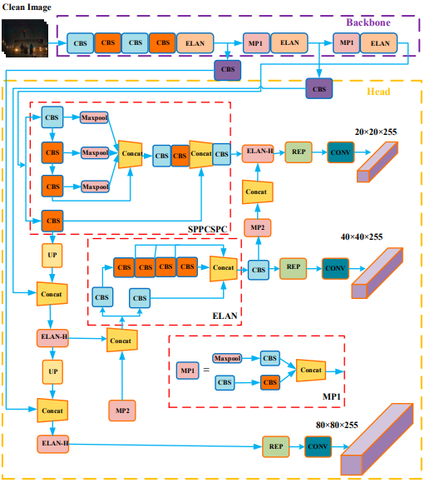

The architecture consists of three layers: input, Backbone and head. Backbone is responsible for extracting features and in this version there are many layers that contain BConv, E-ELAN and MPConv, adding multiple channels additionally for feature extraction. Head is responsible for the predictions and its structure is the combination of layers: SPPCPC, BConv, MPConv, RepVGG block (Rep & Conv with green & Blue colour gives three heads output) and including layers for concatenation.

The YOLOv7 architecture, being a proposed extension to the original YOLO models, has a backbone flow that differs from previous versions. The backbone flow of YOLOv7 involves using the CSPDarknet53 architecture, which includes a cross-stage partial network that helps improve feature representation and reduces the computational complexity of the model. The output of CSPDarknet53 is then fed into a Spatial Pyramid Pooling (SPP) module, which generates multiscale feature maps that are used for object detection at different scales. Next, the multiscale feature maps are processed by a series of convolutional layers, including upsampling layers, which increase the resolution of the feature maps. Finally, the feature maps are used to predict the bounding boxes and class probabilities of objects in the input image.

In summary, the backbone flow of YOLOv7 involves using the CSPDarknet53 architecture to extract features, followed by the SPP module to generate multiscale feature maps, and then using a series of convolutional layers to process the feature maps for object detection..

Delin Wu et al. (2022) proposes his paper about detecting the fruit Camellia oleifera in a complex environment. Author predominantly talks about data augmentation in the paper and named the YOLOv7 as DA-YOLOv7, as he observed by using augmentation of images such as mirroring, brightening & darkening, noise and mosaic augmenting, there is increase in the model performance and accuracy and model YOLOv7 outperformed the existing models like FRCNN, YOLO v5 small, YOLOv3-spp networks. The model performance after training reached mAP of 96.03%, Recall of 95.15%, Precision of 94.76% with prediction time of 0.025s for one image. In the research conducted the author provides a theoretical foundation for crop recognition and harvesting in difficult situations [(Wu et al., 2022)](https://www.zotero.org/google-docs/?HWO15C) [13].

When applying object detection models of detecting humans or smaller objects using drones on the sea surface in real time, it becomes challenging to detect when there is interference of waves and other major sized objects. Author Hangyue Zhao et al. proposes a working model to tackle the situation he uses a Energy Function (EF) which was referred from the paper by Lingxiao Yang et al [30], based on flow of neurons EF can be implemented with few line of script in order to not to lose information from each neuron, it is named as Simple Parameter-Free Attention Module (SimAM).

SimAM replaces conventional modules such as channel-wise & spatial-wise with 3-D weights and it helps to locate attention hotspots of objects in the scene in addition to augmenting and bundled box fusion (WBF). Author says average precision increased seven times i.e.59% for improved YOLOv7 compared to the original version YOLOv7 [(Zhao et al., 2023)](https://www.zotero.org/google-docs/?CABXzD) [14] . This study will assist the scholars in research of maritime scenarios captured by drones during rescue operations.

**Fig: 3-D weights of simAM [30].**

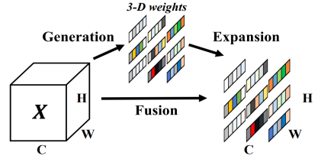

3. YOLOv7 Object detection plays an important role in detecting objects on traditional datasets, but when it comes to classifying in low lighted climatic conditions such as snowfall or night vision for vehicles it becomes really challenging to identify because of weather conditions. Yongsheng Qiu et al. inorder to optimise the issue, infers a module for foggy scenarios named IDOD-YOLOv7.

The proposed model is a combination of existing object detection modules of YOLOv7 and IDOD-YOLOv7 modules. IDOD is specifically built for the purpose of less lighted environments, and it is combination of AOD (removing fog from the image)+ SAIP (enhancing the image) by decreasing the ASM (atmospheric scattering model) proposed by Narasimhan et al. [31], ASM modules are, airlight and attenuation, that extracts complete picture information structure from one or two pictures.

The metrics used for the purpose of image evaluation such as PSNR (peak signal to noise ratio) and SSIM (structural similarity index measure). Author talks about joint optimization methods (defogging and enhancing) for effective learning during the low lighted conditions [(Qiu et al., 2023)](https://www.zotero.org/google-docs/?M8eA8R) [15].

**Fig Image enhancing (SAIP) & defogging (AOD) for YOLOv7 [15]**

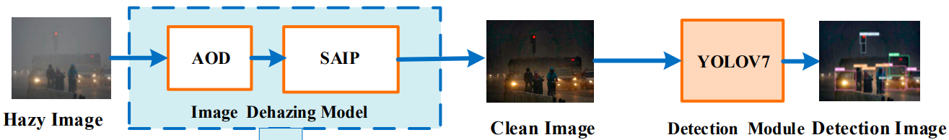

YOLOv7 implementation on steel industry helps to identify the defects and taken respective measures to reduce the faulty material during the process, as model is able to detect the defects in real time with optimal accuracy and speed says Yang Wang et al, for developing the model author uses three different techniques such as BiFPN structure, ECA and loss function of Bounding box is replaced by SIOU. Where by utilising the BiFPN de weighted structure to utilise feature information in order to strengthen the output feature during convolution and decrease feature information loss during the convolution process, and enhance recognition rate. ECA is responsible for making the features strong by considering only channels that matter most. By inheriting all the approaches resulted in a high performance and accurate model with mAP of 80.2% the results are based on two different datasets of steel [(Y. Wang et al., 2022)](https://www.zotero.org/google-docs/?fUU914) [16].

Yolov7 has succeeded in the field of livestock detection with a mAP of 99.5%. The proposer of the paper Munir Ahmad et al. conveys his approach by using three different stages, initial stage of SIFT algorithm for feature extraction, secondly, FLANN as algorithm for recognition of animal breed (muzzle) and check with registered data.The model is trained using transfer learning there after FLANN is used to fetch the related features and matches animal category using Knn (K nearest neighbour). The suggested model and approach has shown great ability in performance and accuracy and is able to detect and distinguish animal faces and noses, and the model acheived the capabilities to be employed in a variety of scenarios, including managing of livestock, tracing animals, and conservation activities [(Ahmad et al., 2023)](https://www.zotero.org/google-docs/?CIq3Kb) [17].

Author Vung Pham et al. able to witness astounding results by implementing Yolov7 for identifying the holes on a path, by using tuning techniques such as label smoothing (reduces overfitting) and augmentation implying on the model which turned to produce amazing results i.e., F1 score of 81.7% on Google Street view dataset and 74.1% for testing dataset. Author uses Google Street View that contains a massive collection of road images around the globe, these pictures are regularly updated, allowing to stay up to date on the updated road conditions. After data gathering, creating labels to train the data. As a result the performance of the model and accuracy increased [(Pham et al., 2022)](https://www.zotero.org/google-docs/?gQIxkl) [18].

## **MobileNet SSD v2**

MobileNetSSD V2 is an object detection model that uses a combination of MobileNet V2 architecture and a Single Shot Detector (SSD) framework. The architecture is outlined in two research papers, "MobileNetV2: Inverted Residuals and Linear Bottlenecks" [(Sandler et al., 2019)](https://www.zotero.org/google-docs/?FqHIeu) and "SSD: Single Shot MultiBox Detector." [(W. Liu et al., 2016)](https://www.zotero.org/google-docs/?w6ZROM) The model begins with a MobileNetV2 backbone, consisting of inverted residual blocks that employ depthwise separable convolutions to reduce computation and enhance mobile device performance.

**Fig: Architecture flow of MobileNet-SSD-V2 network** [**(Chiu et al., 2020)**](https://www.zotero.org/google-docs/?lKtiEo) **[25]**

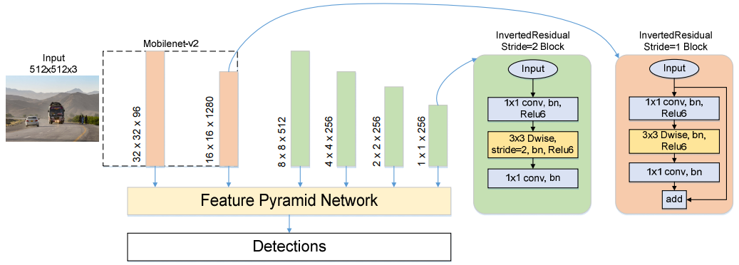

The backbone generates feature maps of different scales that pass through a feature pyramid network. The feature pyramid network uses convolutions to produce feature maps of varying resolutions, enabling object detection at different scales. The detection head consists of convolutional layers that generate bounding box predictions and class probabilities for each feature map. Prior boxes are pre-defined bounding boxes used to generate proposals for objects of different sizes and shapes. The model uses non-maximum suppression to eliminate duplicate detections and keep only the most confident detections for each object.

In summary, the MobileNetSSD V2 model employs a lightweight MobileNetV2 backbone, a feature pyramid network, and an SSD detection head to achieve real-time object detection on mobile device**s**

MobileNet SSD v2 architecture is popular for its speed and less weighted model which produces astounding results of detecting objects in real time and it is built for the installation as an application in mobiles. The following citations stated about the real time aspects of implementing the MobileNet SSD v2, An Expression Recognition Method on Robots Based on Mobilenet V2-SSD [(F. Zhang et al., 2019)](https://www.zotero.org/google-docs/?1B3Hs0), Comparison of the YOLOv3 and SSD MobileNet v2 Algorithms for Identifying Objects in Images from an Indoor Robotics Dataset [(Rios et al., 2021)](https://www.zotero.org/google-docs/?SDYxmO), Recognition of Pedestrian Traffic Light using Tensorflow And SSD MobileNet V2 [(Evan et al., 2020)](https://www.zotero.org/google-docs/?FS0YAk), Face Mask Detection Using SSD-Mobilenet-V2 [(T et al., 2023)](https://www.zotero.org/google-docs/?Lz1xg1), Face Detection in Still Image using SSD MobileNet V2 and Geometrical Algorithm [(Chan et al., 2022)](https://www.zotero.org/google-docs/?ALjRYA),

For the purpose research only few of MobileNet SSD v2 citations have been selected such as, Mobilenet-SSDv2: An Improved Object Detection Model for Embedded Systems [(Chiu et al., 2020)](https://www.zotero.org/google-docs/?jfclDY), MobileNet-SSD MicroScope using adaptive error correction algorithm: real-time detection of license plates on mobile devices [(Hu et al., 2020)](https://www.zotero.org/google-docs/?R7xzEt), An Automatic Traffic Density Estimation Using Single Shot Detection (SSD) and MobileNet-SSD [(Biswas et al., 2019)](https://www.zotero.org/google-docs/?e9GTbT), Implementation of Single Shot Detector (SSD) MobileNet V2 on Disabled Patient's Hand Gesture Recognition as a Notification System [(Nurfirdausi et al., 2021)](https://www.zotero.org/google-docs/?LsmqF7).

Implementation of Mobilent SSD in embedded systems, the author Tu-Chen Chiu et al. conveys through his proposal, the aim of object detection is, how accurately models are capable of distinguishing objects. All the well performed models for object detection do not take reduction of computational complexity as consideration. When MobileNet is applied in embedded systems with limited computing capabilities, the model performs as light weighted object detector in real time additionally including FPN(feature pyramid network) as prediction layer to maintain accuracy. It is considered as an important concept in self-driving systems. Finally, the model in real-time is able to achieve a mAP of 75.9% , parallelly in comparison with MobileNet SSD the v2 is improved up to 3.5% and FPS of 19 in video processing [(Chiu et al., 2020)](https://www.zotero.org/google-docs/?wbWQ5R) [25].

MobileNet-SSD also excelled in detecting small objects such as licence plates on mobile devices with high accuracy. Most of the existing models are meant for vehicle detection and humans, it becomes really challenging when identifying the licensed number plates . The paper by Xun Hu et al. clearly explains the clever predictions obtained in the detection of small licence plates using MobileNet SSD Microscope, which includes an Adaptive Error Correction (AEC) algorithm for the purpose of reducing wrong sensed images, AEC improvises the precision rate and it can be implemented in a wide range of situations. Therefore the model is effectively able to distinguish licence plates, and can be used instantaneously on a smartphone. The suggested model has also shown its ability in reducing the complexity of computation and in extraction of small objects which helps to significantly improve the recall rate [(Hu et al., 2020)](https://www.zotero.org/google-docs/?KuFlQA) [26].

MobileNet SSD application usage to resolve the traffic difficulties in urban areas, author Debojit Biswas et al Compares MobilenetSDD and SSD with performance & Speed as evaluation. SSD can handle objects with varying forms, dimensions, and viewing angles. MobileNet-SSD is a model that has been bridge from SSD to MobileNet, meant for its speed. The analysis conducted on these two models are performed using 59 different cameras. In terms of populated areas SSD showed exceptional results with accuracy of 92.97% whereas FPS 5 to 7 and accuracy of Mobilenet is 79.30% with an FPS 15 to 18. The accuracy of MobilenetSSD increased up to 90.38% when it comes to Macroscopic view of images [(Biswas et al., 2019)](https://www.zotero.org/google-docs/?5Zo7LZ) [27]. Finally to conclude, estimating traffic density during various times of the day would give statistics that can be used to enhance traffic performance in metropolitan networks.

MobileNet for recognizing hand gestures. This project is designed for disabled people who aren’t able to speak, for this purpose the author [Annisaa' F. Nurfirdausi](https://ieeexplore.ieee.org/author/37089193247) et al. used the concept of deep learning techniques for object detection and chose the MobileNet architecture, which is meant for its performance in real time and uses low computation. The dataset is trained on five different hand signs such as to eat, to drink, to use restroom, medicines and help. SSD on MobileNet v2 architecture is used for training instead of other available approaches, which is well suited for real time detection. The model is able to produce mean average precision of 44.7% and in total 100 predictions 85% were detected to be true in comparison to the author's previous models. The FPS of the model is ±2. After the detection the model is integrated as an application in mobile, and the output can be sent as notification in Telegram [(Nurfirdausi et al., 2021)](https://www.zotero.org/google-docs/?41qQSy) [28].

## **Research Gap**

From the above literature review, the citations from various authors have been discussed, and data augmenting techniques will be considered in this topic to improve the accuracy of Hook detection. The research mainly focuses on the model’s YOLOv5, YOLOv7 and MobileNetv2-SSD. These three models have been implemented and compared. The reason behind choosing these 3 models is because of their speed, performance, and ease of use. YOLOv5,v7 models run on the Pytorch framework[9]. Based on the company's protocol towards monitoring the installations in real time, this research focuses on deploying YOLOv5,v7 for Desktop/Cloud version and MobileNet-SSD-V2 for mobile application. From the research, there are no datasets that are available that focus predominantly on Hook data. Firstly, the aim of this proposal is to only concentrate on identifying the hooks and in future implement this similar approach to check the alignment of the hooks. This research will be considered as a starting point, to deploy in real time automation of solar equipment installations. So the research gap is missing hook’s data so the topic is focused on gathering hook data from the known resources and annotating them. More details will be conveyed in the Methodology.

# Methodology

The methodology chapter introduces and discusses in detail, the approach used for detection of the roof hooks that are used for mounting solar panels. Three different deep learning models were used to achieve this goal, namely: YOLOv5s (small), YOLOv7 and MobileNetSSD v2. The application of all three models and specificities related to their unique configurations that make them suitable for the research goal of the master thesis.

The methodology has been formulated according to the best practices identified in the literature. All the acquired knowledge was further extended to accommodate it to the purposes of the research question . Hereby, the methodology chapter is structured in a way to expose all the logic behind the research. The following sections describe the dataset used, the preprocessing steps applied to the images, and the training and evaluation process of each model. Furthermore, the hyperparameter tuning and performance metrics used to compare the models are likewise described.

Overall, the methodology offers a thorough strategy for object detection utilising the deep learning models. For YOLOv5s , YOLOv7 and MobileNetSSD v2 the common steps in the data preprocessing pipeline were followed. In the case of the two versions of YOLO model data augmentation techniques used to increase the diversity of the training data, whereas the data augmentation is not included for the MobileNetSSD v2. Additionally, the same data preparation steps, such as resizing the images to a fixed size, converting them to the appropriate format, and normalising the pixel values to a range between 0 and 1 pursue the same logic for all three selected models. Any differences that exist in their performance, are due to the variations in their architecture and parameters, rather than the ways the input data is processed.

**Data Collection**

The data used for the purposes of the research are the images of the roof hooks (Fig: ) taken during the solar system installation process. Enpal GmbH has a collection of databases where diverse information is stored. Among others a dedicated application (CraftOS) developed internally for organising and supervision of the solar systems construction has its own database. Here, the photo documentation of all the integral stages of the installation process and components including roof hooks are stored. For the purpose of this topic initial step Hooks data is collected from the database. Total number of images collected is 392, it was further augmented to nearly 1000 with different techniques for the models YOLOv5s and YOLOv7 for generalisation. The data of the hooks from the database were extracted based on the unique ids which are assigned to specific categories of the images in the database. For a better understanding the images were titled following a specific naming convention where the first part states the object class i.e. hook and the second part defines the sequential order. The images as a result range from “*hook_1*” to “*hook_392*”.The images are captured from wide range of angles from far & near and different times of the day and the image resolution varies from image to image and it is resized during the pre-processing steps depending on the requirement of the model.

**Dataset Preparation**

In order to successfully apply the YOLO model, preprocessing of the data is necessary. For instance the YOLOv5s architecture is expecting the images of size 3 x 416 x 416 as an input. This standardisation ensures that all images have a uniform size and aspect ratio, making it easier for the model to learn the features of the objects in the same images during the training process. This practice also helps to minimise the memory requirements for training and inference, which is particularly important for large datasets or resource-constrained devices. Resizing the images to a smaller size improves the training process while maintaining the model's accuracy.

…..

## **Data Augmentation**

As specified above, in total 392 images were acquired. Meanwhile, based on the conducted literature research , it was found out that a sample of 1000 images per class is considered as a good practice. In his paper [(Hu et al., 2021)](https://www.zotero.org/google-docs/?AYf7hZ) stated that in order to enhance the performance of the YOLOv5s model, techniques such as encompassed random flipping, cropping, scaling, rotation, Gaussian noise addition, colour jittering, and random erasing should be applied. By doing so from the initial 392 images, a final dataset of 892 images was prepared. These techniques were employed to improve the model's accuracy by diversifying the training data and avoiding overfitting. Besides, the model can potentially learn more about different scenarios during the training process.

For instance [Deng et al. (2020)](https://www.zotero.org/google-docs/?xCKU91) emphasises the significance of data augmentation as a method to enhance the performance of deep learning models for object detection. Data augmentation techniques are implemented to increase the diversity and quantity of training data, thereby improving the model's robustness. The same approach is also supported by [Kim et al. (2022)](https://www.zotero.org/google-docs/?tULlCN) who in addition to the techniques mentioned above suggests using motion blur and random adjustments to brightness, contrast, and saturation, that can contribute to the precision of the model

Table of Techniques used

| Technique name | Number of images | Sample image | Applied |
| --- | --- | --- | --- |
| Contrast | 250 |  |  |
| Darken | 250 |  |  |
|  |  |  |  |

TECHNIQUES YOU HAVE APPLIED?

For the purpose of this research LabelImg tool has been used for the purpose of labelling, the image below shows how the annotations looks like

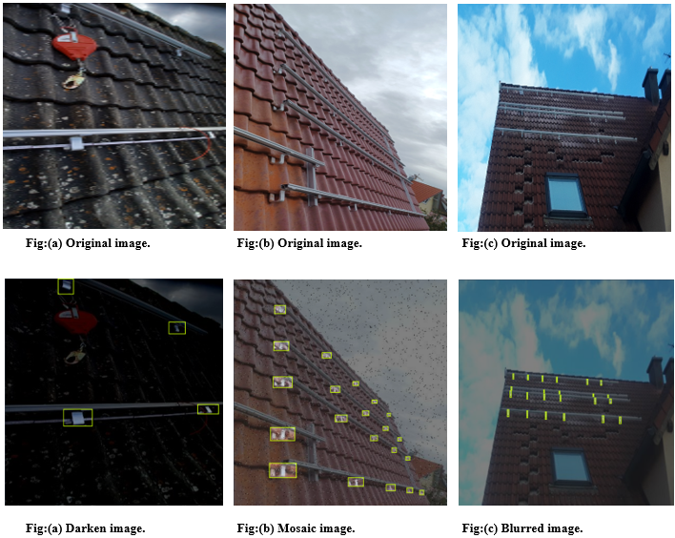

**Labelling process**

LabelImg is a widely used open-source tool for annotating images that can be used to train machine learning models. . It is a graphical tool that allows users to draw bounding boxes around objects of interest in an image and assign labels to them.

The tool allows to load individual or multiple images in different formats such as JPEG, PNG, and BMP. Annotation of images is done by drawing bounding boxes around objects and by assignment of specific labels or classes. Once the images are annotated, it can be saved in a compatible format such as Pascal VOC, YOLO, or TensorFlow.

Finally annotated images can be used to train an object detection model using a preferred framework like Tensorflow, Pytorch and Darknet/YOLO. LabelImg's intuitive interface and support for different annotation formats make it a popular tool for object detection tasks. The current research uses Labelimg for the proposed models YOLOv5, YOLOv7 and MobileNet SSD v2. For both YOLO versions, after creating a bounding box or ROI (region of interest) in the tool, a “.txt” file will be created for every image processed. The text file contains height, width, x,y coordinates, and the class of the bounding boxes.

**Training, testing and validation**

In machine learning, it is a common practice to divide a dataset into a training set, a validation set, and a testing set. This approach allows, to evaluate the performance of a model. In this particular scenario, the model is trained with a training set of 772 images which is approximately 87% of the total dataset. The validation set consists of 80 images i.e., 9% of the total dataset. It is used to track the performance of the model while training and also to aid in hyperparameter tuning, such as modifying batch sizes and learning rates. After the training is completed, the testing set consisting of 40 images i.e. 4% of the dataset is utilised to carry out the final assessment of the model's performance.

Splitting the dataset into three separate sets enables us to measure the model's ability to generalise to unfamiliar and unseen data. This approach helps prevent overfitting, which occurs when the model memorises the training data instead of learning the underlying patterns, and can result in poor performance on new data.

**Configuration file**

In general, a configuration file is used to define the required settings and parameters for training an object detection model, including the image size, dataset path (e.g.: *train: Hook-Detection-1/train/images*), number of classes (only one class i.e. Hook), anchors with aspect ratios of different sizes at different scales and other related configurations. The use of a configuration file enables the model to be trained in a reproducible, flexible, and organised manner, making the training process more efficient and maintainable.

**YOLOv5s Model Architecture**

There are many versions in YOLOv5 such as YOLOv5s, YOLOv5m, YOLOv5l, etc[10]. Choosing the model depends on the speed, resources for computation and accuracy. OLOv5sv5s is considered special because of its efficiency and speed. It can achieve real-time performance on low-power devices, such as mobile phones and embedded systems, while still maintaining a reasonable level of accuracy. It is also relatively easy to train and fine-tune, which makes it a popular choice for researchers and practitioners in the field of computer vision. Its architecture includes CSPDarknet53 feature extraction layers and YOLOv5 prediction layers. The CSPDarknet53 is an optimised version of the Darknet architecture that enhances feature reuse and reduces computational cost using cross-stage partial connections.

The prediction layers use convolutional layers to predict bounding boxes, objectness scores, and class probabilities for each grid cell. During training, YOLOv5s uses labelled image and bounding box data and a loss function that punishes errors in object localization, objectness prediction, and class prediction. Batch size of 16 with 200 epochs has been used for maintaining reasonable balance between the speed and accuracy. For larger data however a bigger batch size is required.

The configurations for the YOLOv5s incorporate the following building blocks that specify what the model architecture looks like. In order to provide a better insight into the architecture presented in Figure XX the following parameters should be discussed. This architecture lies under the model used to try to answer the research question of this master thesis.

The following is the flowchart of the YOLOv5s model which has been proposed and utilised in this research:

**Fig: Flowchart of YOLOv5s model**

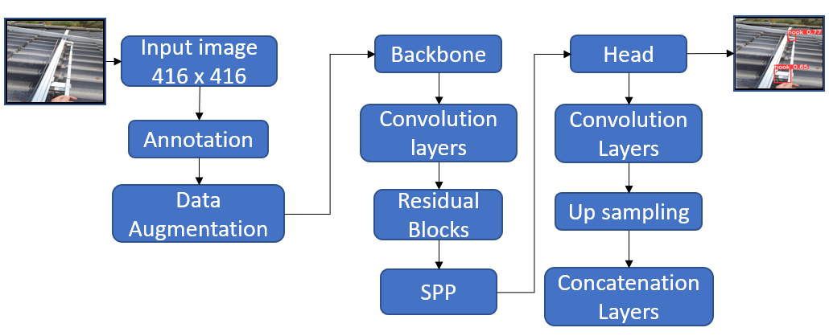

The configuration of YOLOv5s model can be done by adjusting two main components it consists of - Backbone and Head. These components are the combination of convolutional layers, bottleneckCSP, sampling, concatenating and detection layers. For the purpose of reference the complete configuration file.has been provided in the Appendix.

The BottleneckCSP residual block is a new feature that is first introduced to version five of YOLO and should improve the efficiency and accuracy of deep neural networks by reducing the computational cost and the number of parameters required while still maintaining high performance.

The YOLOv5s Backbone includes a series of convolutional layers, residual blocks, and spatial pyramid pooling layers, designed to process input images to detect objects. When an input image of (416, 416, 3) dimensions is feeded in, the process starts with the Backbone level. Its first layer is a Focus layer with 64 output channels and a kernel size of 3 (reason for choosing the kernel size is computation time and accuracy makes the number based on many existing trails) used for the purpose of downsampling and feature extraction. This is followed by a convolutional layer with 128 output channels and a kernel size of 3, which again downsample the image by a factor of 2.

Next come several BottleneckCSP residual blocks for the purpose of refinement of features. Each of them contains 128, 256, or 512 output channels, designed to extract feature maps at different scales. The final layer in the backbone is a spatial pyramid pooling layer (SPP) that has a purpose to capture the context of features at different scales. The SPP contains 1024 output channels and pooling operations using multiple kernel sizes, providing a comprehensive approach to feature extraction.

After all Backbone stages are over, the process moves on to the next main level - the Head. The head is responsible for predicting bounding boxes and class probabilities for the detected objects. It begins with a convolutional layer with 512 output channels and a kernel size of 1, followed by an upsampling layer, doubling the spatial dimensions of the tensor. The output is then concatenated with the feature map from the P4 layer of the backbone.

This is followed by several BottleneckCSP residual blocks with 512 output channels. Subsequently, the head includes a convolutional layer with 256 output channels and a kernel size of 1 Next comes an upsampling layer and concatenation with the feature map from the P3 layer of the backbone. This is followed by several BottleneckCSP residual blocks with 256 output channels, for the purpose of smaller objects in the image.

The head also includes a convolutional layer with 256 output channels and a kernel size of 3, which downsamples the image by a factor of 2. The output is then concatenated with the feature map from the P4 layer of the head, followed by several BottleneckCSP residual blocks with 512 output channels, for the purpose of medium-sized objects.

Lastly, the head includes a convolutional layer with 512 output channels and a kernel size of 3, which downsamples the image by a factor of 2. The output is then concatenated with the feature map from the P5 layer of the head, followed by several BottleneckCSP residual blocks with 1024 output channels, for the purpose of larger objects in the image.

To conclude, the output of the head goes through the process of detecting bounding boxes using specified anchors provided in the configuration file. In the end the v5s model can forecast bounding boxes and class probabilities for the identified objects, giving a complete method for object detection.

**YOLOv7 Model Architecture**

The YOLOv7 model is an advanced object detection framework that has been extensively trained to recognize a diverse set of 80 unique object types, such as vehicles, humans, and animals, among others. Unlike other object detection models that rely on simplistic techniques, the YOLOv7 model employs a convolutional neural network (CNN), which is akin to a complex array of filters that can comprehend a wide array of intricate patterns within an image.

The YOLOv7 model can be broken down into two primary sections, the "backbone" and the "head." The backbone comprises a sophisticated sequence of 11 convolutional layers and max pooling layers that work in tandem to extract vital features from the image data. On the other hand, the head consists of five convolutional layers and upsampling layers that help to analyse the extracted features and identify objects within the image with precision and accuracy.

To optimise this intricate process and further enhance its effectiveness, the YOLOv7 model utilises a powerful feature known as "anchor boxes". These predefined geometric shapes are used to provide the model with a better understanding of the size and location of various objects within the image, resulting in a higher degree of accuracy while reducing the number of false positives - instances where the model incorrectly identifies an object.

Overall, the YOLOv7 model is an incredibly powerful and sophisticated tool that enables the automated detection of objects within images. The training process of the model is configured to work with a batch size of 16, running for 100 epochs, resulting in a highly efficient and rapid model that is well-suited for real-time applications where speed is critical.

The architecture of v7 is explained in the following according to the configuration file and the steps of the anchors,backbone and head are provided in the Appendix.

**Fig: Flowchart of YOLOv7 model**

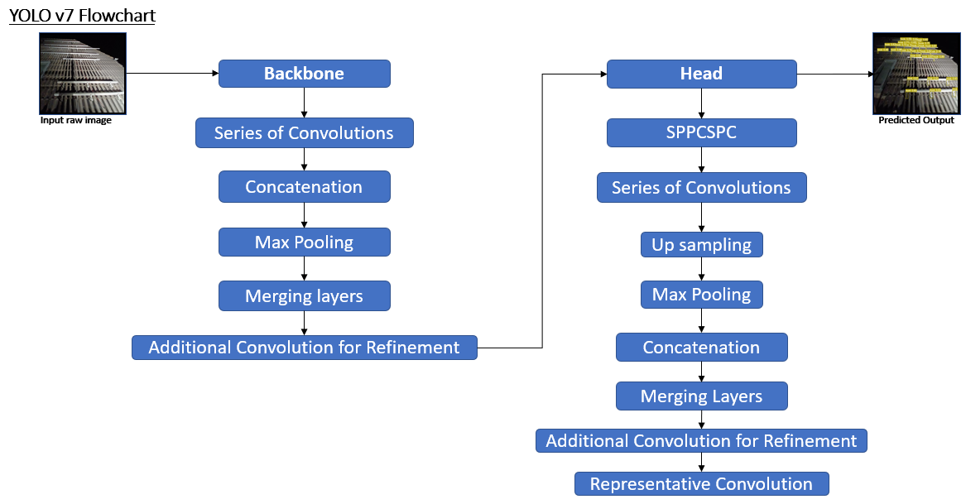

**Backbone**

**Step 1:**

* Layer 0: Conv (output channels = 32, kernel size = 3, stride = 1)

This stage applies an initial convolution to the input image, capturing basic features like edges and textures.

**Step 2:**

* Layer 1: Conv (output channels = 64, kernel size = 3, stride = 2)
* Layer 2: Conv (output channels = 64, kernel size = 3, stride = 1)

This stage applies two convolutional layers, refining the features and increasing the depth of the feature maps while reducing spatial dimensions.

**Step 3:**

* Layer 3: Conv (output channels = 128, kernel size = 3, stride = 2)
* Layer 4-9: A series of Conv layers (output channels = 64, kernel sizes = 1 or 3, stride = 1)
* Layer 10: Concat (concatenate feature maps from layers 4,5,7 and 9)
* Layer 11: Conv (output channels = 256, kernel size = 1, stride = 1)

This stage applies multiple convolutional layers and a Concat operation to combine multi-scale information from different layers. A subsequent Conv layer further refines the features.

**Step 4:**

* Layer 12: Max Pooling
* Layers 13-15: A series of Conv layers (output channels = 128, kernel sizes = 1 or 3, strides = 1 or 2)
* Layers 16: Concat (concatenate feature maps from layers 13, 15)
* Layers 17-22: A series of Conv layers (output channels = 128, kernel sizes = 1 or 3, strides = 1)
* Layer 23: Concat (concatenate feature maps from layers 16, 18, 20, and 21)
* Layer 24: Conv (output channels = 512, kernel size = 1, stride = 1)

This stage includes Max Pooling to reduce spatial dimensions, applies a series of convolutional layers, and performs a Concat operation to combine multi-scale information. A Conv layer 24 in the end refines the features.

**Step 5:** (Similar to Step 4. Max Pooling, Conv, Concatenating, refine feature maps using Convolution).

**Step 6:** (Similar to Step 4. Max Pooling, Conv, Concatenating, refine feature maps using Convolution). The last Conv layer refines the high-level features that will be passed to the head detection of YOLOv7 to predict bounding boxes around the object and probability of the class.

**Head**

**Step 1 (SPP and CSPC):**

* Layer 51: (SPPCSPC) is responsible for applying the Spatial Pyramid Pooling and CSP structure to the input feature map (output channels = 512) take the input features from the backbone architecture.

**Step 2 (Upsampling and merging with P4):**·

* Layers 52-55: Consist of a series of Conv (output channels = 256, kernel sizes = 1, strides = 1) , Upsample, and Concat operations that upsample the feature map and merge it with backbone P4's feature map.

**Step 3 (Processing the merged feature maps):**·

* Layers 56 - 61: Consist of a series of Conv (output channels, 2 layers of 256, and 4 layers of 128, kernel sizes = 1, strides = 1)
* Layer 62: Concatenate feature maps from layers 43, 44, 46, and 48).
* Layer 63: Conv (output channels = 256, kernel sizes = 1 or 3, strides = 1 or 2) that refines the merged feature maps.

**Step 4 (Same as step 2, merging with P3):**

**Step 5 (Similar to Step 3. Conv, Concatenating, refine feature maps using Convolution):**

**Step 6 (Processing the merged feature maps):**

* Layers 76: Max Pooling
* Layers 77 - 79: consist of a series of Conv layers (output channels = 128, kernel sizes = 1 or 3, strides = 1 or 2).
* Layer 80: Concatenation features of layers (63, 77 and 79).

**Step 7 (Similar to Step 3. Conv, Concatenating, refine feature maps using Convolution):**

**Step 8 (Similar to Step 6. Max Pooling, Conv, Concatenating, refine feature maps using Convolution):**

**Step 9 (Similar to Step 3. Conv, Concatenating, refine feature maps using Convolution):**

**Step 10 (Representative Convolution and Detection):**

* Layers 102: It is represented as RepConv as it takes the feature maps from the specified step. [75, 1, RepConv, [256, 3, 1]], 75 is the concatenation step that contains the feature maps of previous layers, 1 is how many times this operation is performed. Also, the Series of RepConv layers (output channels = 256 , kernel sizes = 3, strides = 1).
* Layers 103: The Series of RepConv layers (output channels = 512, kernel sizes = 3, strides = 1).
* Layers 104: The Series of RepConv layers (output channels = 1024, kernel sizes = 3, strides = 1).
* Layer 105: (IDetect) uses the processed feature maps from the previous step to predict object bounding boxes and class probabilities.

**MobileNet-SSD-v2 Model Architecture**

This MobileNetV2 convolutional neural network architecture is designed to be highly efficient and powerful, surpassing its predecessor MobileNetV1 in many ways. This is accomplished through the incorporation of two novel and highly impactful features - inverted residuals and linear bottlenecks - that serve to optimise the model's performance.

The architecture of MobileNetV2 starts with the process of taking an image as input and subsequently passing it through a series of convolutional layers. These layers use small filters to effectively reduce the spatial dimensions of the feature map without compromising the high levels of accuracy that the model is capable of. The model then employs bottleneck blocks and inverted residual blocks that facilitate the learning of complex features while simultaneously utilising a smaller number of parameters. The output from these blocks is then added to the input by way of element-wise addition, which enhances the model's performance and accuracy.

To further optimise the computational cost of the model, the architecture uses linear bottlenecks and downsampling blocks. The linear bottlenecks are adept at using pointwise convolutions to reduce the number of input channels, while the downsampling blocks rely on depthwise convolutions with a stride of 2 to effectively reduce the spatial dimensions of the feature map. These actions serve to further reduce the computational costs of the model without negatively impacting its performance or accuracy.

Overall, MobileNetV2 represents a significant leap forward in the field of object detection, showing great potential to be able to detect in real time that is embedded on mobiles. Its innovative and efficient architecture, coupled with its incorporation of powerful features such as inverted residuals and linear bottlenecks, make it more efficient in terms of speed and accuracy.

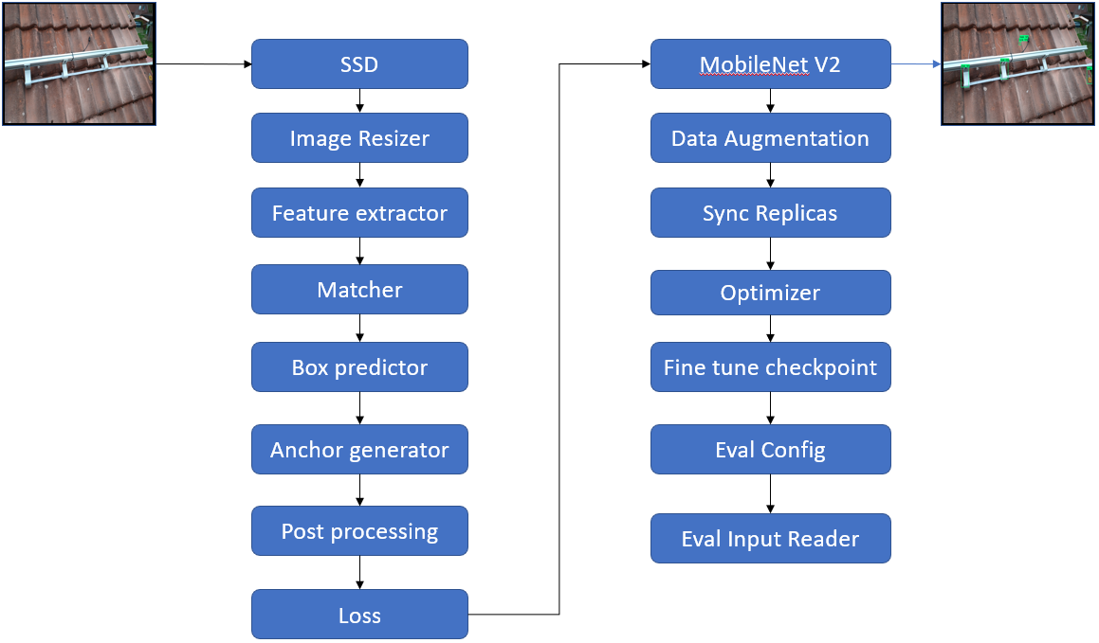**Fig: () The flow chart of the MobileNet SSD V2**

The process used for making MobileNet SSD v2 architectural flow is as follows, and the configuration file is available in the Appendix.

**SSD**

* **Image_resizer** is the first block of the model that takes the input image of height, width of 320 x 320 as a fixed size.
* Next stage is the \***feature_extractor** (fe). The type used by fe is “ssd_mobilenet_v2_fpn_keras” , fe also includes various parameter tuning techniques such as initializer, activation function, and regularisation. The FPN values are set to minimum of 3 and maximum of 7, the purpose of the FPN is to detect the objects at different aspect ratios, in this context 3 and 7 are spatial resolutions which means lower resolution 3 gives the pictures of lower quality of the image with higher pixel values, and vice versa with maximum 7. Subsequently, “Use_depthwise” is set to true,which serves as a convolution layer as it reduces the computations and attributes from the convolution which makes it more efficient than the traditional convolution.
* **Box_coder** is used for encoding and decoding the coordinates of the bounding box when the model is trained, here **faster_rcnn_box_coder** as coder for the bounding box, it contains four scaling featuresy_scale and x_scale which are set to 10.0 for the purpose of balancing weights during the loss of vertical (y_scale) and horizontal (x_scale) positions , height_scale and width scale which are set to 5.0 these parameters are responsible for reducing loss (weights) in terms of height and width of the bounding box.
* **Matcher** is used for matching the anchors of the predicted box with the ground truth bounding box. Here the matches uses **argmax_matcher** for deleting the anchors which are under IoU threshold, the threshold values are set to be matched_threshold and unmatched_threshold both as 0.5, the IoU rejects the predicted anchors which are less than 0.5 and additional parameters like negatives_lower_than_unmatched, force_match_for_each_row, and use_matmul_gather are used to remove negative anchors, provide anchor box by matching with ground truth box though the value under IoU threshold.
* **\*Box_predictor** is used for providing scores for the detected object along with the coordinates. Here **weight_shared_convolutional_box_predictor** is defined with various parameters, conv_hyperparams first subclass in weight_shared_convolutional_box_predictor thatcontains the parameters for convolution layers, for instance l2_regulaizer with weights of 4e-05 is used to prevent overfitting similarly other functions are initializer, activation, and batch_norm are utilised. Subsequently 4 prediction layers before the final prediction layer with kernel_size of 3 are defined. Finally use_depthwise is set to true to reduce the computation complexity and size of the model.
* **Anchor_generator** provides the anchor boxes for the model, for this purpose **multiscale_anchor_generator** is used for generating the anchor boxes. The parameters used here are, min_level:3 for detecting the objects at higher spatial resolution, max_level:7 for lower resolutions, 3 different aspect_ratios are provided for defining the size of anchor boxes with values 1.0 for square, 2.0 (twice as wide as its tall), and 5.0 (twice as tall as its wide).
* **Post_processing** takes after the model makes predictions, it refines the predictions. The Post_processinguses **batch_non_max_suppression** block which includes various parameters for removing the low scored boxes by using score_threshold where threshold is set to 1e-08. IoU threshold for removing overlapped boxes, the value of threshold is set to 0.6. Max_detection s_per_class and max_total_detections for allowing per class to 100 predictions and in total of 100 predictions. Finally, the score_converter sigmoid is used for converting the raw scores into probabilites.
* **Loss** includes various components that contain normalisation and loss. The component **Normalize_loss_by_num_matches** is set to true as the function balances the loss of objects (anchor boxes) from different pictures so that the model can contribute equally for more and less objects in an image. Furthermore, functions like localization_loss , classification_loss, classification_weight, localization_weight are set to value of 1, encode_background_as_zeros, normalize_loc_loss_by_codesize, inplace_batchnorm_update are set to true, all these parameters are designed for training the model, and balancing the loss during the process of training. Changing these parameters will show an impact on the performance of the model and convergence.

**Train_config:** The training file of train_config contains various settings as follows

* Batch_size set to 4, which makes the input flow of images in the model can process 4 images at a single stretch.
* **Data_augmentation** is used by the model for the purpose of better generalisation of pictures and the techniques used for the augmentation are random_horizantal_flip and random_crop images.
* **Sync_replicas** is set to true which indicates that a distributed training takes place in the model, as many similar versions of the model will be trained on multiple devices and in order to keep them consistent the weights are synced at regular intervals.
* **Optimizer**: In order to improve the performance of the model the learning rate of the deep learning model has to be optimised gradually, for this purpose cosine_decay_learning_rate is introduced which contains the techniques such as learning_rate_base of 0.08 is the starting learning rate, total_steps of 50000, warmup_learning_rate of 0.026666, and warmup_steps set to 1000 for the purpose of reducing the learning rate. data_augmentation_options, optimizer, momentum_optimizer
* **Fine_tune_checkpoint**  specifies the path for the pre-trained model MobileNet SSD v2 which is the starting point for the training and number of training steps is set to 50000 and additional components include replicas_to_aggregate of 8 the weights of the model is aggregated from 8 different replicas , max_number_of_boxes of 100 which tells the maximum number of ground truth boxes present inside image, unpad_groundtruth_tensors set to “false” specifies the ground truth boxes are not padded to predetermined sizes, fine_tune_checkpoint_type set to “detection”, and fine_tune_checkpoint_version is “V2”.
* **Eval_config** is used for evaluating the model and the metrics provided are “coco_detection_metrics” which consists of mAP & recall. use_moving_average is set to false, as it is not suited for model evaluation.
* **Eval_input_reader**  is used during the evaluation of the model. The components provided are tf_record_input_reader specifies the path of the training or evaluation data in the form of records. label_map_path tells the location for the label_map file by specifying the class_names and ids in order to evaluate the model properly. Num_epochs set to 1 so the evaluation takes only once.

**Weight file**

During the training a weight file is used, to store the learned parameters of the model. It can be saved and loaded for future use or transferred to another similar model architecture. The weight file is critical for fine-tuning a pre-trained model or initialising a new model. It enables the model to build upon the learned features from previous training, leading to improved performance.

**Results and Discussion**

**YOLOv5s**

The following demonstrates three different approaches using YOLOv5s.

**YOLOv5 batch size 8 and epochs 50 results**

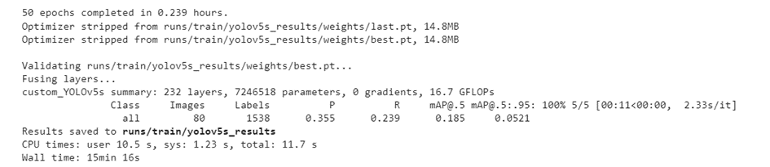**Fig: () The results of YOLOv5s of batch size 8 and epochs 50**

The YOLOv5s model has undergone 50 epochs of training and produced a mean average precision (mAP) of 0.185 on the validation set. The model contains a total of 232 layers and 7,246,518 parameters. During the validation process, this model detected 80 images containing a total of 1,538 objects, achieving a precision of 0.355 and a recall of 0.239. The last and best checkpoint files were stripped resulting in a reduced file size of 14.8 MB. To validate the model, the best checkpoint file was utilised, and the outcomes were preserved to the specified directory.

Based on these findings, it appears that the YOLOv5s model trained on the dataset has performed sub-optimally. This may suggest that further optimization and fine-tuning are necessary to enhance the model's performance and make it more appropriate for real-world applications.

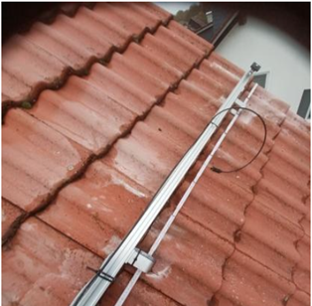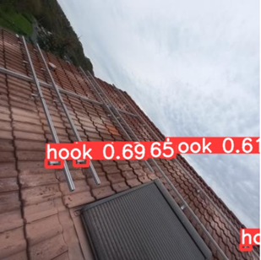 **Fig:() Near hook detection**  **Fig:() Far hook detection**

The pictures presented above have been taken from two different angles. Image in Fig:1 was captured from closer distance while the other one in Fig: 2, has been captured from greater distance. In the where the model failed to create the bounding box for the hooks in Fig: 1 compared to the Fig:2 The results shows that the model is able to perform better when it is captured from long distance

Below is the graphical representation of the training the model over 50 epochs.

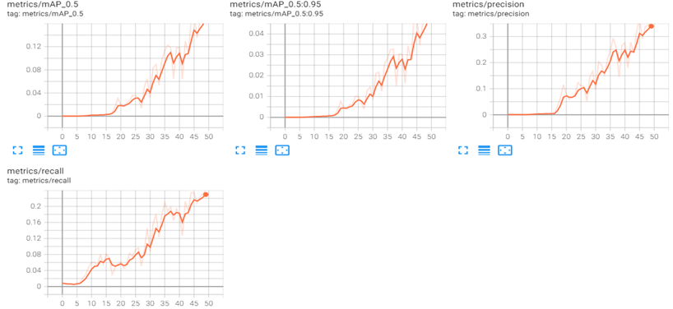  **Figure Graphical representation of the Metrics for Batch 8 and epochs 50**

**YOLOv5 batch size 12 and epochs 100 results**

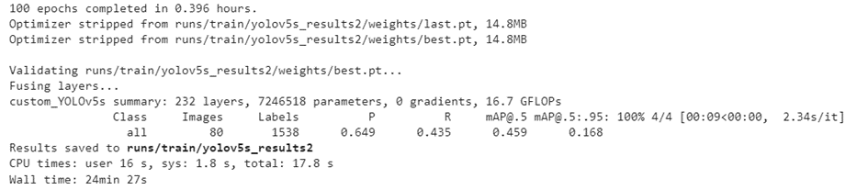**Fig: () The results of YOLOv5s of batch size 12 and epochs 100**

Upon analysing the previous performance of the model, one can deduce that the YOLOv5s model underwent rigorous training for a substantial amount of time, a total of 100 epochs to be precise, leading to an impressive overall mean average precision (mAP) of 0.459 on the validation set. During the validation process, this model achieved a precision of 0.649 and recall of 0.435.

Furthermore, it was observed that the optimizer underwent a stripping process from the last and best checkpoint files, eventually resulting in a significantly smaller file size of 14.8 MB. Subsequently, the best checkpoint file was utilised to validate the model's performance, and the results were saved to the designated directory. The achieved results indicate that the YOLOv5s model successfully completed the challenging task of object detection using the provided dataset. However, despite the model's performance, further optimization and fine-tuning like changing the batch size, learning rate may be required.

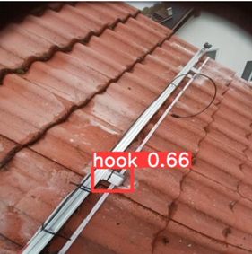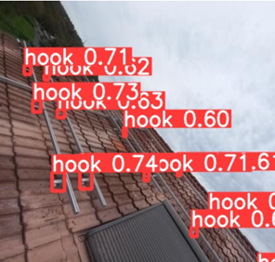 **Fig:() Near hook detection**  **Fig:() Far hook detection**

Image in Fig:1 was captured from closer distance while the other one in Fig: 2, has been captured from greater distance. From the first picture the model was able to detect the hook and create a bounding box with a probability of 66%. The results show that the model is able to perform better on both scenarios by making the batch size to 12 and increasing the number of epochs to 100.

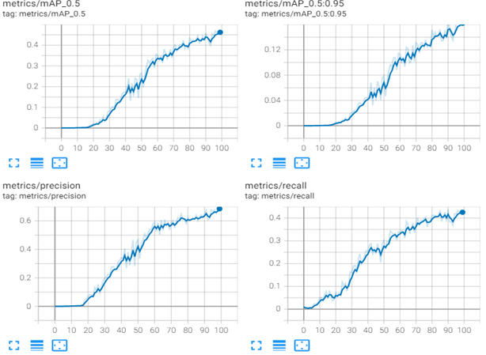 **Figure () shows the Graphical representation of the Metrics for Batch 12 and epochs 100**

**YOLOv5 batch size 16 and epochs 200 results**

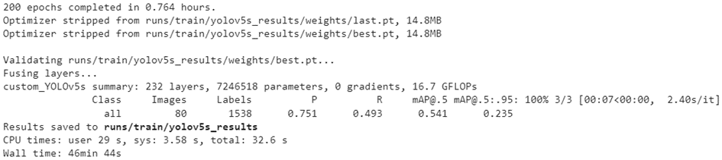**Fig: () The results of YOLOv5s of batch size 16 and epochs 200**

Building upon the previous information, it is noteworthy that the YOLOv5s model has undergone extensive training for 200 epochs, taking approximately 0.679 hours to reach completion. Stripping the optimizer from both the last and best checkpoint files has led to a compressed file size of 14.8 MB, ensuring optimal storage efficiency. During the validation process, the model successfully acheived precision value of 0.751 and a recall value of 0.493. Additionally, the mean average precision (mAP) of the model was 0.541 at a threshold of 0.5 and 0.235 at a threshold of 0.5 to 0.95, indicating that the model has achieved excellent results for the object detection task.

It can be concluded that the YOLOv5s model trained on the specified dataset has performed outstandingly, signifying that it could be an ideal option for real-world applications. Thus, it is essential to highlight that the YOLOv5s model's accuracy can be significantly improved by implementing additional optimizations, resulting in a more efficient model that is more suitable for practical applications.

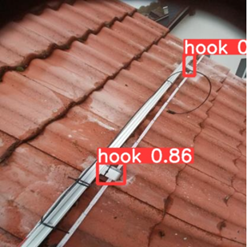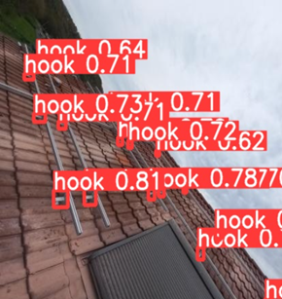 **Fig:() Near hook detection**  **Fig:() Far hook detection**

From the above pictures Fig: 1 and Fig: 2 the performance of the model is further increased compared to the above two different methods. This model is able to detect the hooks with the highest probability and it is able to detect almost all the hooks. The results show that the model’s detection capacity and probability increased when the batch size was changed to 16 and the epochs made to 200.

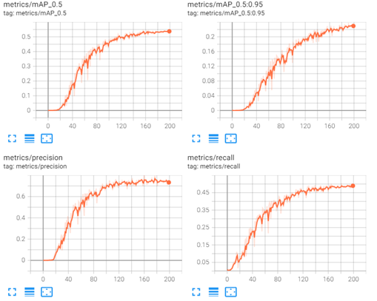 **Figure( ) Graphical representation of the Metrics for Batch 16 and epochs 200**

The provided information indicates that the YOLOv5s model's performance improved with an increase in the number of training epochs and increase in batch sizes and based on different trial and testing, batch size 16 is considered to be the best. The model trained for 100 epochs and batch size 12 achieved a mean average precision (mAP) of 0.459 on the validation set, while the model trained for 200 epochs and batch size 16 achieved a higher mAP of 0.541. The model trained for 50 epochs and batch size 8 produced the lowest mAP of 0.185.

Additionally, it's important to note that the optimizer was stripped from all three checkpoint files, resulting in a smaller file size of 14.8 MB for each. During validation, the model detected 80 images containing a total of 1,538 objects, achieving precision and recall values ranging from 0.355 to 0.751 and 0.239 to 0.493, respectively.

Regarding training time, the model trained for 100 epochs took 0.396 hours, while the model trained for 200 epochs took longer at 0.679 hours. The model trained for 50 epochs was the fastest at 0.239 hours.

Overall, the model trained for 200 epochs achieved the best performance in terms of mAP, with a moderate increase in training time compared to the model trained for 100 epochs. Therefore, training the YOLOv5s model for 200 epochs is the best approach for this dataset and object detection task.

**YOLOv7 (v7)**

**YOLOv7 batch size 12 and epochs 85 results**

The YOLOv7 model has undergone 85 epochs of training and produced a mean average precision (mAP) of 0.71 on the validation set.. The model contains a total of 314 layers and 37196556 parameters. During the validation process, this model detected 80 images containing a total of 1,530 objects, achieving precision of 0.89 and a recall of 0.61. The last and best checkpoint files were stripped resulting in a reduced file size of 78.4 MB. To validate the model, the best checkpoint file was utilised, and the outcomes were preserved to the specified directory.

The YOLOv7 architecture is designed in a way that it is well suitable for real time detections for cloud or pc, because of its massive architecture and time it takes to train the model which generates astounding results. The model is trained with the batch size of 12 with epochs of 85. The model proved to be successful in detecting hooks. Check the pictures from Fig: 1 and Fig: 2. The weight file after training is 78.4 MB, where the best weights during the training step are chosen for predicting the hooks. Below the pictures are the results of unseen images predicted by the model.

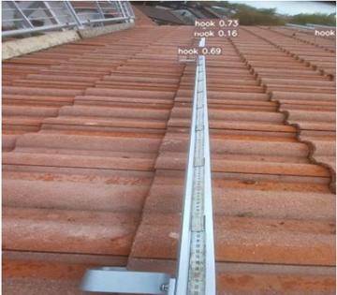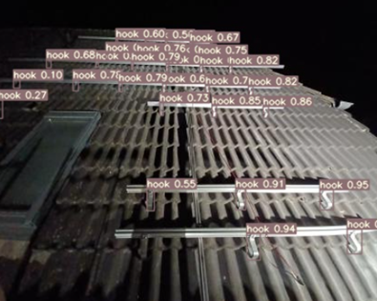 **Fig:() Near hook detection**  **Fig:() Far hook detection**

The reason for choosing the 85 epochs is that there is no improvement in the model from the graph. The model maintained a stagnant line after certain epochs which led the model to get stopped at step 85. The following graphical representation of the metrics, the learning curve of precision and recall can be seen.

Based on these findings, it appears that the v7 with batch size 12 trained on the dataset has performed really well in detecting hooks which are far and but unable to detect which are near, for instance in Fig: 1 and Fig: 2 where the model is not able to create bounding box for the hooks that are near. This suggests the model's performance makes it more appropriate for real-world applications.

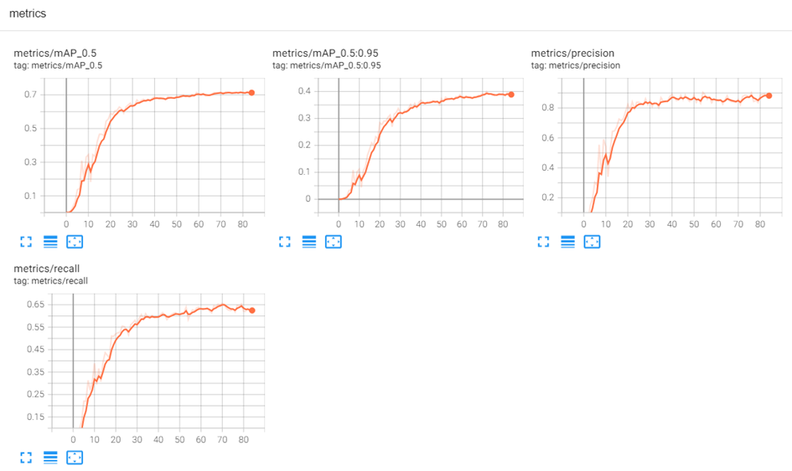**Fig() Graphical representation of Batch 12 and epochs 85 results.**

**YOLOv7 batch size 16 and epochs 85 results**

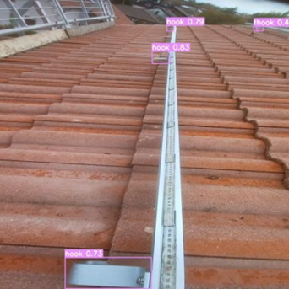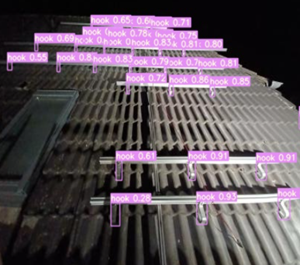 **Fig:() Near hook detection**  **Fig:() Far hook detection**

The YOLOv7 model has undergone extensive training over the course of 85 epochs, resulting in a mean average mAP of 0.71 on the validation set. This powerful model boasts an impressive 314 layers and an astounding 3,64,81,772 parameters. During the validation process, the YOLOv7 model successfully identified 80 images containing a total of 1,530 objects, achieving a precision of 0.88 and a recall of 0.63. The last and best checkpoint files were stripped, resulting in a reduced file size of 78.4 MB. To validate the model, the best checkpoint file was utilised, and the outcomes were preserved to the specified directory.

The results suggest that the v7 model with batch size 16 performed exceptionally well in detecting hooks both near and far, making it an ideal choice for real-world applications. The architecture of YOLOv7 is designed to be well-suited for real-time detections in cloud or PC environments, given its massive architecture and the time it takes to train the model to generate astounding results.

Interestingly, the performance of the model improved when the batch size was increased from 12 to 16 with 85 epochs of training, taking 1.206 hours to complete. Both approaches achieved similar results, but this method proved more successful in detecting nearby hooks. The weight file after training is 78.4 MB, and the best weights during the training step were chosen for predicting the hooks. Check out the pictures from Fig: 1 and Fig: 2 for a closer look at the model's performance.

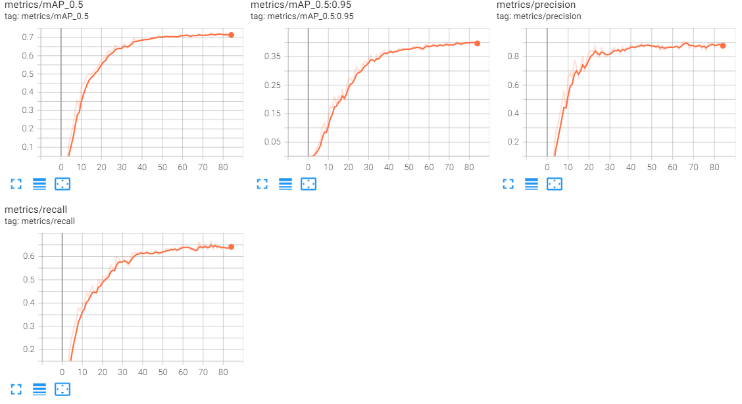**Fig() Graphical representation of Batch 16 and epochs 85 results.**

**MobileNetSSD v2**

The MobileNet SSD v2 is the other state of the art deep learning model which. The reason behind using this model is its speed with backend up support of SSD and it is compatible with mobile. It was named SSD Mobilenet as it is backend supported by the single shot detector SSD to maintain its accuracy. Initially the model has been trained with 50 annotated images out of which 40 for training and 10 for testing, trained the model with the fewer number of images as a kick start for the model to check how the prediction works on the unknown image. The results were not up to the mark but there can be seen a bounding box has been created check Fig: 1.

Later the training of models with the number of images increased to a total of 400, out of that 320 for training and 80 for testing, and the training steps set to 2000. The probability of the predicted class values were very less, but the bounding boxes around the detected object were nearly accurate although there are outliers which can be seen in Fig 2.

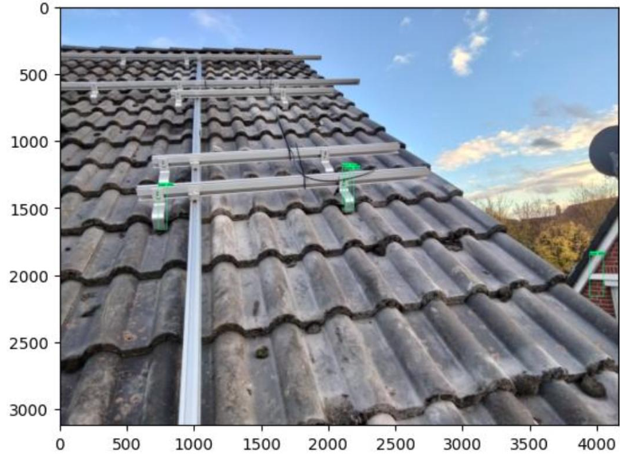 **Fig (1) Model with 50 images and 2000 trained steps. Fig (2) Model with 392 images and 2000 trained steps.** 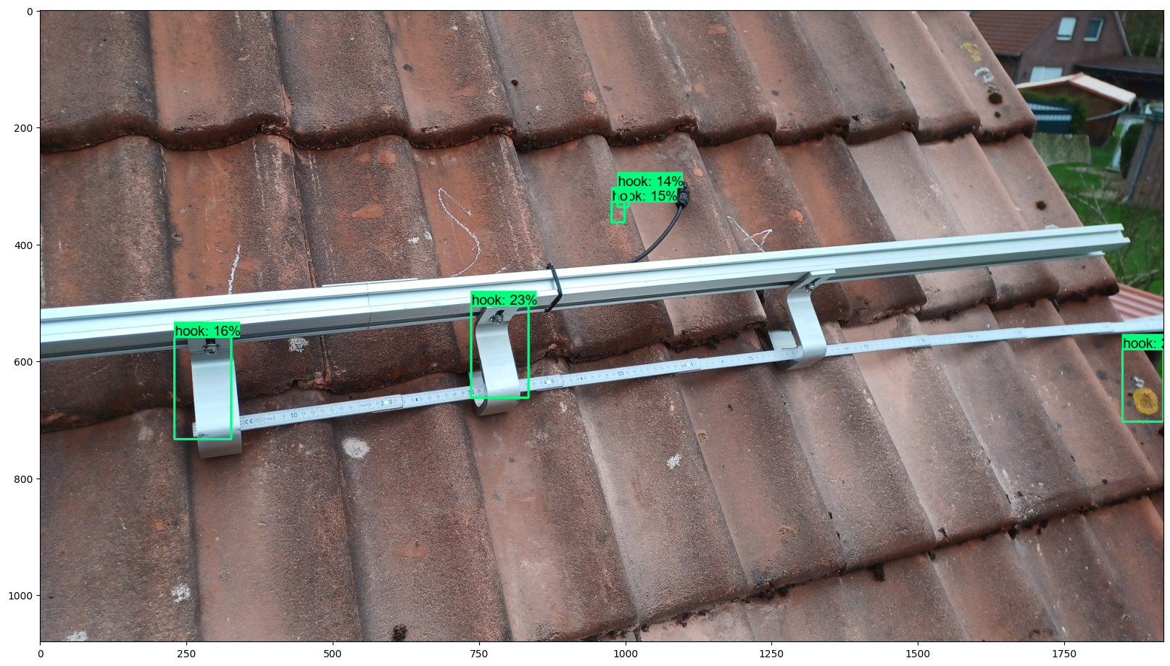

From the above it can be stated that increasing the count of images led to magnificient output. Following that, try raising the number of training stages from 2000 to 4000 to see if it has any effect on the model's performance. Below is the output of hook detection trained on 4000 steps.

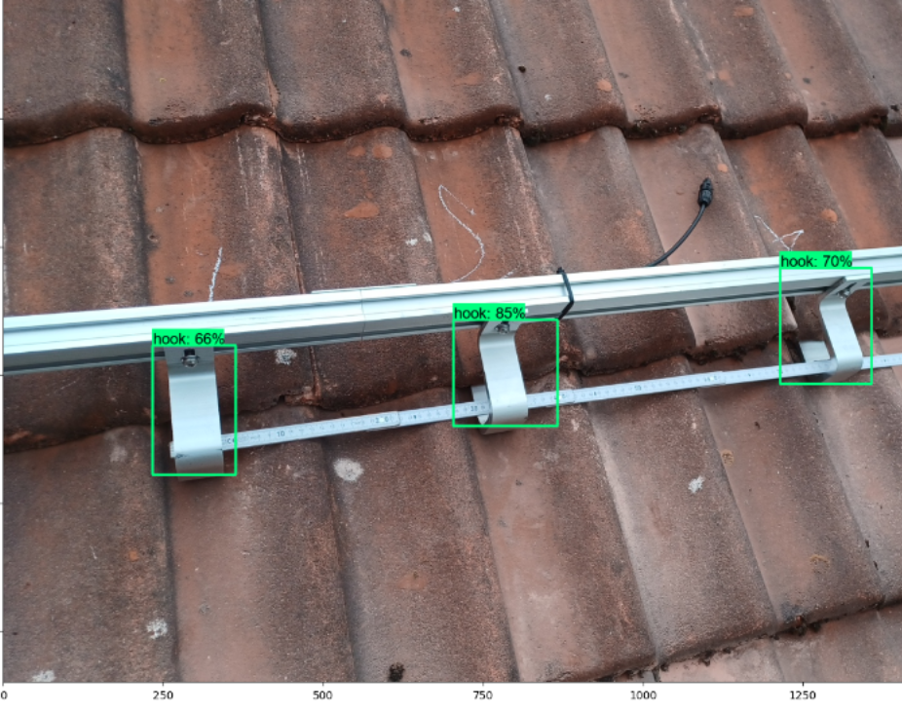 **Fig: () MobileNet prediction at training step 4000**

From the observation the performance of the model is improved by increasing the number of epochs. The model's convergence (learning rate) remained the same for the both training steps, but the loss of the model decreased from 0.32 to 0.18, as a result the prediction rate was increased.

The next important note, successfully training and testing the model. Evaluating the model was not possible. Based on the research the reasons might be: the first the coordinates of the annotating image was mismatched with the x,y axis and another reason the model accepts the pixel size of 320x320.

**Conclusion**

The three different object detection models trained on the Hook’s dataset provide impressive outcomes by utilising the robust YOLOv5s, YOLOv7, and MobileNetSSD V2 architects. The models YOLOv5s and Mobilenet designed for the purpose of installing as mobile applications can be used for real time scenarios. These models can be further improved by changing a few parameters like increasing the number of images, regularisation, learning rate, and by resorting to certain additional augmenting methods for generalisation.

Overall outputs produced by the

##### Strength and weaknesses of the models used ######

# model architecture: -> preparation yolo v5s is architectural layers are less comparatively to the same version of v5x, v5l, v5m, for the purpose of fast detecting the spatial dimensions are reduced in every layers by preserving the accuracy·

# performance: -> processing for ex: accuracy and speed of the model,

it is performed poor when the images are far

# results quality

-> outputs ·

# possible improvement

options ·

# context -> where can it be implemented in future for ex: at

enpal

The **YOLO v5s (v5s)** model main strength that can be considered is its ability to detect the objects with its high inference speed by maintaining its accuracy. The size of its weight file makes it suitable for embedding it as a mobile application. When it comes to improvement the model is unable to detect the objects which are captured from far. Adding additional labelled images which are taken from long distance with perfect labelling and giving little additional convolution layers for extracting more feature maps and tuning some hyper parameters improves the detection more effectively. Moreover, the time taken to train the model was nearly 40 minutes which is half less than the version 7 of YOLO, which tells the speed of the training is faster. In the real world applications the v5s model is a standard bench mark to detect the objects in real time using mobiles. The weight file makes it fit for platforms like mobiles. This research case can be added for other scenarios, such as checking the distance of the components, and alignment of vertical and horizontal positioning of the solar hooks.

The **YOLO v7 (v7)** model main strength that can be considered is its ability to detect the objects with optimal accuracy. However the accuracy was detained when prediction of the objects which are lowlighted environments, for instance pictures taken during night, the probability of detection was about 50-60% for certain objects inside the image. Which means that there is not sufficient data that has been labelled during the pictures captured during lowlighted environments. In order to improve, adding additional images with diverse lighting conditions makes the model generalise more effectively. Moreover, the time taken to train the model was almost 80 minutes, which can be further reduced by decreasing the spatial dimensions (length & width) of the image during the convolutional operation, by closely monitoring the performance (loss & learning rate) of the model. In the real world applications the v7 model is impressive in terms of object detection. The weight file makes it fit for platforms like Cloud or PC. The research case can be added for other scenarios, such as checking the distance of the components, and alignment of vertical and horizontal positioning of the solar hooks.

The **MobileNet SSD V2** model's main strength is that it can be able to detect the objects with high inference speed and acceptable accuracy. The weight file makes it fit for platforms like Mobiles. From the outputs during the training steps the (classification_loss, localization_loss and regularization_loss) are reduced as increased in the number of training steps which is the sign that model is learning. The drawbacks of this model as it shows the low probability for the detected objects, in order to completely rely on the model, from the finding maintaining 85% percent of the probability can be considered as a righteous model. For further improvements the data augmentation is needed which provides additional data that includes degraded images such as jitter, noise and blurred will help the model to learn more and achieve better results. Moreover, the time taken to train the model was almost 80 minutes, the model is unable to detect the objects which are captured from far. In this research, based on the outcomes and performance of MobinetSSD V2 it is difficult to rely on the model for checking the distance of the components, and alignment of vertical and horizontal positioning of the solar hooks in real time in comparison with v5s unless it is further improved with optimal accuracy.

##### Part future research possibilities#####

The next goal of this research is to try different models. Possible candidates can be YOLOv5l, YOLOV5x and YOLOv6 that according to the literature offer more complex architecture and can thus produce noteworthy results.

These alternatives are still confined within the YOLO family boundaries. In order to contribute to the theory and add append the comparative research a further insight into other models that are built both on Tensorflow and PyTorch frameworks. Among others RCNN, F-RCNN and Masked RCNN that are built on the Darknet framework can be of great interest.

**Appendix:**

**YOLOv5 configuration text file:**

The purpose of a requirements.txt file is to list the Python packages and versions needed for a project, manage dependencies, and create a virtual environment. The command "pip install -r requirements.txt" can be used to install the required packages.

* gitpython>=3.1.30
* matplotlib>=3.2.2
* numpy>=1.18.5
* opencv-python>=4.1.1
* Pillow>=7.1.2
* psutil # system resources
* PyYAML>=5.3.1
* requests>=2.23.0
* scipy>=1.4.1
* thop>=0.1.1 # FLOPs computation
* torch>=1.7.0 # see https://pytorch.org/get-started/locally (recommended)
* torchvision>=0.8.1
* tqdm>=4.64.0
* tensorboard>=2.4.1
* pandas>=1.1.4
* seaborn>=0.11.0
* setuptools>=65.5.1 # Snyk vulnerability fix

**Config file**

# parameters

* nc: 1 {num_classes} # number of classes
* depth_multiple: 0.33 # model depth multiple
* width_multiple: 0.50 # layer channel multiple

**Anchors:**

* [10,13, 16,30, 33,23] # P3/8
* [30,61, 62,45, 59,119] # P4/16
* [116,90, 156,198, 373,326] # P5/32

In the anchor box concept it consists of rectangles of different size and aspect ratios, the above mentioned numbers are paired, aspect ratios refers to the width to height ratio of an object or bounding box surrounding it. By designing anchor boxes with different aspect ratios (for ex: 10:13, 16:30 and 33:23), the model can detect objects with varying shapes and sizes in the image. For instance p3/8 decreases scale of the input image by 8 times i.e. if input image is 416 then it will be reduced to 52 and the anchors boxes are randomly chosen according to the scale, and the aspect ratios increase as increase in the scale. Therefore, a model can detect objects of various sizes and aspect ratios in an input image with high accuracy and efficiency by utilising multiple scales and associated anchor values.

**backbone:**

# [from, number, module, args]

* [
* [-1, 1, Focus, [64, 3]], # 0-P1/2
* [-1, 1, Conv, [128, 3, 2]], # 1-P2/4
* [-1, 3, BottleneckCSP, [128]],
* [-1, 1, Conv, [256, 3, 2]], # 3-P3/8
* [-1, 9, BottleneckCSP, [256]],
* [-1, 1, Conv, [512, 3, 2]], # 5-P4/16
* [-1, 9, BottleneckCSP, [512]],
* [-1, 1, Conv, [1024, 3, 2]], # 7-P5/32
* [-1, 1, SPP, [1024, [5, 9, 13]]],
* [-1, 3, BottleneckCSP, [1024, False]], # 9
* ]

For the purpose of understanding this research by explaining the first 3 steps will give an idea about how the backbone architecture of v5 functions . From the first section It has 3x3 filters up to 64 and it is referred to as 64 channels, -1 is used to take input image of anysize. Focus is to reduce the input image size by preserving the features this is achieved by downsample the input image and extract the features at multiple scales before proceeding to the further networks. In the next layer “-1” takes the default value of the number of filters used , conv represents a standard operation of convolution with 3x3 filters up to 128 channels with a stride of 2.

# YOLOv5 head

**head:**

* [
* [-1, 1, Conv, [512, 1, 1]],
* [-1, 1, nn.Upsample, [None, 2, 'nearest']],
* [[-1, 6], 1, Concat, [1]], # cat backbone P4
* [-1, 3, BottleneckCSP, [512, False]], # 13
* [-1, 1, Conv, [256, 1, 1]],
* [-1, 1, nn.Upsample, [None, 2, 'nearest']],
* [[-1, 4], 1, Concat, [1]], # cat backbone P3
* [-1, 3, BottleneckCSP, [256, False]], # 17 (P3/8-small)
* [-1, 1, Conv, [256, 3, 2]],
* [[-1, 14], 1, Concat, [1]], # cat head P4
* [-1, 3, BottleneckCSP, [512, False]], # 20 (P4/16-medium)
* [-1, 1, Conv, [512, 3, 2]],
* [[-1, 10], 1, Concat, [1]], # cat head P5
* [-1, 3, BottleneckCSP, [1024, False]], # 23 (P5/32-large)
* [[17, 20, 23], 1, Detect, [nc, anchors]], # Detect(P3, P4, P5) ]

**YOLOv7 configuration text file**

# parameters

nc: 80 # number of classes

depth_multiple: 1.0 # model depth multiple

width_multiple: 1.0 # layer channel multiple

**Anchors:**

* [12,16, 19,36, 40,28] # P3/8
* [36,75, 76,55, 72,146] # P4/16
* [142,110, 192,243, 459,401] # P5/32

**Backbone:**

# [from, number, module, args]

* [[-1, 1, Conv, [32, 3, 1]], # 0
* [-1, 1, Conv, [64, 3, 2]], # 1-P1/2
* [-1, 1, Conv, [64, 3, 1]],
* [-1, 1, Conv, [128, 3, 2]], # 3-P2/4
* [-1, 1, Conv, [64, 1, 1]],
* [-2, 1, Conv, [64, 1, 1]],
* [-1, 1, Conv, [64, 3, 1]],
* [-1, 1, Conv, [64, 3, 1]],
* [-1, 1, Conv, [64, 3, 1]],
* [-1, 1, Conv, [64, 3, 1]],
* [[-1, -3, -5, -6], 1, Concat, [1]],
* [-1, 1, Conv, [256, 1, 1]], # 11

* [-1, 1, MP, []],
* [-1, 1, Conv, [128, 1, 1]],
* [-3, 1, Conv, [128, 1, 1]],
* [-1, 1, Conv, [128, 3, 2]],
* [[-1, -3], 1, Concat, [1]], # 16-P3/8
* [-1, 1, Conv, [128, 1, 1]],
* [-2, 1, Conv, [128, 1, 1]],
* [-1, 1, Conv, [128, 3, 1]],
* [-1, 1, Conv, [128, 3, 1]],
* [-1, 1, Conv, [128, 3, 1]],
* [-1, 1, Conv, [128, 3, 1]],
* [[-1, -3, -5, -6], 1, Concat, [1]],
* [-1, 1, Conv, [512, 1, 1]], # 24
* [-1, 1, MP, []],
* [-1, 1, Conv, [256, 1, 1]],
* [-3, 1, Conv, [256, 1, 1]],
* [-1, 1, Conv, [256, 3, 2]],
* [[-1, -3], 1, Concat, [1]], # 29-P4/16
* [-1, 1, Conv, [256, 1, 1]],
* [-2, 1, Conv, [256, 1, 1]],
* [-1, 1, Conv, [256, 3, 1]],
* [-1, 1, Conv, [256, 3, 1]],
* [-1, 1, Conv, [256, 3, 1]],
* [-1, 1, Conv, [256, 3, 1]],
* [[-1, -3, -5, -6], 1, Concat, [1]],
* [-1, 1, Conv, [1024, 1, 1]], # 37

* [-1, 1, MP, []],
* [-1, 1, Conv, [512, 1, 1]],
* [-3, 1, Conv, [512, 1, 1]],
* [-1, 1, Conv, [512, 3, 2]],
* [[-1, -3], 1, Concat, [1]], # 42-P5/32
* [-1, 1, Conv, [256, 1, 1]],
* [-2, 1, Conv, [256, 1, 1]],
* [-1, 1, Conv, [256, 3, 1]],
* [-1, 1, Conv, [256, 3, 1]],
* [-1, 1, Conv, [256, 3, 1]],
* [-1, 1, Conv, [256, 3, 1]],
* [[-1, -3, -5, -6], 1, Concat, [1]],
* [-1, 1, Conv, [1024, 1, 1]], # 50
* ]

**Head:**

* [[-1, 1, SPPCSPC, [512]], # 51
* [-1, 1, Conv, [256, 1, 1]],
* [-1, 1, nn.Upsample, [None, 2, 'nearest']],
* [37, 1, Conv, [256, 1, 1]], # route backbone P4
* [[-1, -2], 1, Concat, [1]],
* [-1, 1, Conv, [256, 1, 1]],
* [-2, 1, Conv, [256, 1, 1]],
* [-1, 1, Conv, [128, 3, 1]],
* [-1, 1, Conv, [128, 3, 1]],
* [-1, 1, Conv, [128, 3, 1]],
* [-1, 1, Conv, [128, 3, 1]],
* [[-1, -2, -3, -4, -5, -6], 1, Concat, [1]],
* [-1, 1, Conv, [256, 1, 1]], # 63
* [-1, 1, Conv, [128, 1, 1]],
* [-1, 1, nn.Upsample, [None, 2, 'nearest']],
* [24, 1, Conv, [128, 1, 1]], # route backbone P3
* [[-1, -2], 1, Concat, [1]],
* [-1, 1, Conv, [128, 1, 1]],
* [-2, 1, Conv, [128, 1, 1]],
* [-1, 1, Conv, [64, 3, 1]],
* [-1, 1, Conv, [64, 3, 1]],
* [-1, 1, Conv, [64, 3, 1]],
* [-1, 1, Conv, [64, 3, 1]],
* [[-1, -2, -3, -4, -5, -6], 1, Concat, [1]],
* [-1, 1, Conv, [128, 1, 1]], # 75
* [-1, 1, MP, []],
* [-1, 1, Conv, [128, 1, 1]],
* [-3, 1, Conv, [128, 1, 1]],
* [-1, 1, Conv, [128, 3, 2]],
* [[-1, -3, 63], 1, Concat, [1]],
* [-1, 1, Conv, [256, 1, 1]],
* [-2, 1, Conv, [256, 1, 1]],
* [-1, 1, Conv, [128, 3, 1]],
* [-1, 1, Conv, [128, 3, 1]],
* [-1, 1, Conv, [128, 3, 1]],
* [-1, 1, Conv, [128, 3, 1]],
* [[-1, -2, -3, -4, -5, -6], 1, Concat, [1]],
* [-1, 1, Conv, [256, 1, 1]], # 88
* [-1, 1, MP, []],
* [-1, 1, Conv, [256, 1, 1]],
* [-3, 1, Conv, [256, 1, 1]],
* [-1, 1, Conv, [256, 3, 2]],
* [[-1, -3, 51], 1, Concat, [1]],
* [-1, 1, Conv, [512, 1, 1]],
* [-2, 1, Conv, [512, 1, 1]],
* [-1, 1, Conv, [256, 3, 1]],
* [-1, 1, Conv, [256, 3, 1]],
* [-1, 1, Conv, [256, 3, 1]],
* [-1, 1, Conv, [256, 3, 1]],
* [[-1, -2, -3, -4, -5, -6], 1, Concat, [1]],
* [-1, 1, Conv, [512, 1, 1]], # 101
* [75, 1, RepConv, [256, 3, 1]],
* [88, 1, RepConv, [512, 3, 1]],
* [101, 1, RepConv, [1024, 3, 1]],
* [[102,103,104], 1, IDetect, [nc, anchors]], # Detect(P3, P4, P5)
* ]

**MobileNetSSD v2 Configuration text file:**

* **model** {
* ssd {
* num_classes: 1
* image_resizer {
* fixed_shape_resizer {
* height: 320
* width: 320
* }
* }
* **feature_extractor** {
* type: "ssd_mobilenet_v2_fpn_keras"
* depth_multiplier: 1.0
* min_depth: 16
* conv_hyperparams {
* regularizer {
* l2_regularizer {
* weight: 4e-05
* }
* }
* initializer {
* random_normal_initializer {
* mean: 0.0
* stddev: 0.01
* }
* }
* activation: RELU_6
* batch_norm {
* decay: 0.997
* scale: true
* epsilon: 0.001
* }
* }
* use_depthwise: true
* override_base_feature_extractor_hyperparams: true
* **fpn** {
* min_level: 3
* max_level: 7
* additional_layer_depth: 128
* }
* }
* **box_coder** {
* faster_rcnn_box_coder {
* y_scale: 10.0
* x_scale: 10.0
* height_scale: 5.0
* width_scale: 5.0
* }
* }
* **matcher** {
* argmax_matcher {
* matched_threshold: 0.5
* unmatched_threshold: 0.5
* ignore_thresholds: false
* negatives_lower_than_unmatched: true
* force_match_for_each_row: true
* use_matmul_gather: true
* }
* }
* similarity_calculator {
* iou_similarity {
* }
* }
* **box_predictor** {
* weight_shared_convolutional_box_predictor {
* conv_hyperparams {
* regularizer {
* l2_regularizer {
* weight: 4e-05
* }
* }
* **initializer** {
* random_normal_initializer {
* mean: 0.0
* stddev: 0.01
* }
* }
* activation: RELU_6
* batch_norm {
* decay: 0.997
* scale: true
* epsilon: 0.001
* }
* }
* depth: 128
* num_layers_before_predictor: 4
* kernel_size: 3
* class_prediction_bias_init: -4.6
* share_prediction_tower: true
* use_depthwise: true
* }
* }
* **anchor_generator** {
* multiscale_anchor_generator {
* min_level: 3
* max_level: 7
* anchor_scale: 4.0
* aspect_ratios: 1.0
* aspect_ratios: 2.0
* aspect_ratios: 0.5
* scales_per_octave: 2
* }
* }
* **post_processing** {
* batch_non_max_suppression {
* score_threshold: 1e-08
* iou_threshold: 0.6
* max_detections_per_class: 100
* max_total_detections: 100
* use_static_shapes: false
* }
* score_converter: SIGMOID
* }
* normalize_loss_by_num_matches: true
* **loss** {
* localization_loss {
* weighted_smooth_l1 {
* }
* }
* classification_loss {
* weighted_sigmoid_focal {
* gamma: 2.0
* alpha: 0.25
* }
* }
* classification_weight: 1.0
* localization_weight: 1.0
* }
* encode_background_as_zeros: true
* normalize_loc_loss_by_codesize: true
* inplace_batchnorm_update: true
* freeze_batchnorm: false
* }
* }
* **train_config** {
* batch_size: 4
* data_augmentation_options {
* random_horizontal_flip {
* }
* }
* **data_augmentation_options** {
* random_crop_image {
* min_object_covered: 0.0
* min_aspect_ratio: 0.75
* max_aspect_ratio: 3.0
* min_area: 0.75
* max_area: 1.0
* overlap_thresh: 0.0
* }
* }
* sync_replicas: true
* **optimizer** {
* momentum_optimizer {
* learning_rate {
* cosine_decay_learning_rate {
* learning_rate_base: 0.08
* total_steps: 50000
* warmup_learning_rate: 0.026666
* warmup_steps: 1000
* }
* }
* momentum_optimizer_value: 0.9
* }
* use_moving_average: false
* }
* fine_tune_checkpoint:"Tensorflow\\workspace\\pre-trained-models\\ssd_mobilenet_v2_fpnlite_320x320_coco17_tpu-8\\checkpoint\\ckpt-0"
* num_steps: 50000
* startup_delay_steps: 0.0
* replicas_to_aggregate: 8
* max_number_of_boxes: 100
* unpad_groundtruth_tensors: false
* fine_tune_checkpoint_type: "detection"
* fine_tune_checkpoint_version: V2
* }
* **train_input_reader** {
* label_map_path: "Tensorflow\\workspace\\annotations\\label_map.pbtxt"
* tf_record_input_reader {
* input_path: "Tensorflow\\workspace\\annotations\\train.record"
* }
* }
* **eval_config** {
* metrics_set: "coco_detection_metrics"
* use_moving_averages: false
* }
* **eval_input_reader** {
* label_map_path: "Tensorflow\\workspace\\annotations\\label_map.pbtxt"
* shuffle: false
* num_epochs: 1
* tf_record_input_reader {
* input_path: "Tensorflow\\workspace\\annotations\\test.record"
* }
* }

**References**

[1] Object Detection with Convolutional Neural Networks by [Yağmur Çiğdem Aktaş](https://yagmurcigdemaktas.medium.com/?source=---two_column_layout_sidebar----------------------------------)

[2] Anchor Boxes — The key to quality object detection by Anders Christiansen

[3] How to Label Images for Object Detection, Step by Step by Pranjal Saxena

[4] GAIA: A Transfer Learning System of Object Detection that Fits Your Needs BYXingyuan Bu 2,4* Junran Peng 1,3* Junjie Yan 4 Tieniu Tan 1,3 Zhaoxiang Zhang 1,3† 1University of Chinese Academy of Sciences, 2Beijing Institute of Technology 3Center for Research on Intelligent Perception and Computing, CASIA, 4SenseTime Group Limited

1. Bias is the difference between the predicted output and actual ground truth.
2. variance is the lack of learning/ memorising during training and poor performance on the Unknown/test dataset.
3. Softmax is an activation function, responsible for classifying the image in the final layer of the model.
4. Sigmoid activation function is used for binary classification.
5. Bag of Freebies refers to implementing a few techniques during training that helps to improve the optimization process of deep neural networks and increase the ability of the performance,the process includes data augmentation, mixup, and label smoothing.
6. Bag of Specials refers to a set of changes in the architecture of CNNs, such as feature pyramid networks and path aggregation networks, which can further improve their performance.
7. A batch size is used as a parameter in CNN for better performance of the network, larger the batch size the better the accuracy, in conspiracy what specific batch size needed is not concluded, proposed by (Pavlo M. Radiuk [51]).
8. Network pruning is a process of optimising the network’s size by taking off parameters and preserving accuracy [(Blalock et al., 2020)](https://www.zotero.org/google-docs/?b53nSj)
9. Pytorch framework is more compatible in comparison to Darknet framework.
10. The letter next to the version stands for the size, namely small, medium and large accordingly.